**Journal:** Ecological Applications

**Manuscript** **type**: Article

**Title:** Antecedent climate drives divergent, long-term restoration outcomes in the Western Great Plains, USA.

**Authors**: Adam L. Mahood*, David M. Barnard, Jacob A. Macdonald, Timothy R. Green, Robert H. Erskine

*corresponding author: [admahood@gmail.com](mailto:admahood@gmail.com)

**Affiliations**: Water Resources, USDA-ARS

**ORCIDs**: ALM: 0000-0003-3791-9654

DMB: 0000-0003-1877-3151

TRG: 0000-0002-1441-8008

**Open Research Statement:** Data and code are provided for peer review in a private repository, and will be made public upon publication.

**Keywords**: Bromus tectorum, Cheatgrass, Conservation Reserve Program, Ecosystem Restoration, Interannual Climate Variability, Plant Functional Groups, Pascopyrum smithii, Western Wheatgrass

# 

# Abstract

Converting croplands to grasslands can restore ecosystem functions and services. But there is uncertainty about why some restoration treatments succeed and others do not. Existing restoration strategies tailor species compositions of seed mixes according to mean conditions in hardiness zones. But individual years typically deviate from average climate norms such that restoration activities may be better informed by recent conditions than with climate averages in order to best direct management strategies. We monitored a field in eastern Colorado that was converted from wheat-fallow to native perennial grassland via seeding. The same seed mix was used to seed half the strips in 2013 (drier) and the other half in 2014 (wetter). The strips seeded in 2013 had only one native grass and shrub species from the seed mix establish, whereas in 2014 all native grasses established Higher soil moisture preceding seed application was positively associated with perennial grasses, while rhizomatous grasses, shrubs and introduced annuals were associated with other variables. We found evidence of facilitatory interactions between grasses and forbs, and antagonistic interactions between native perennial grasses and introduced annuals. These findings can assist land managers to improve upon current approaches by considering antecedent conditions during restoration planning.

# 

# Introduction

Understanding how species diversity develops in novel ecosystems such as post agricultural landscapes is one of most important questions in plant science today [(Armstrong *et al.*, 2023; Bell *et al.*, 2023)](https://www.zotero.org/google-docs/?GsMHGg). Globally, about 15 Mkm2 (10% of global land area) are currently managed as croplands, and this has led to an estimated 133 Pg in cumulative C emissions throughout human history [(Sanderman, Hengl and Fiske, 2017)](https://www.zotero.org/google-docs/?q3d3de). Reestablishing native perennial plant cover in post agricultural landscapes is an important way to restore these systems to C sinks and enhance ecosystem functions and services. However, restoration practitioners have a difficult task in re-establishing native plants in areas managed for long periods as intensive agriculture, because often the native seed bank is depleted, soil fertility has declined, non-native plants are abundant, and ecohydrological function is altered [(Turnbull *et al.*, 2012)](https://www.zotero.org/google-docs/?US6JNB). Furthermore, restoration practitioners are often guided by mean annual climate conditions when they decide which species to plant. But a typical year will tend to have a combination of high, low or average seasonal values of temperature, precipitation and other climate variables, and precipitation in particular can be very difficult to predict. Therefore, “mean conditions” rarely capture climate extremes that drive community responses , especially in drylands.

In the United States, the USDA’s Conservation Reserve Program (CRP) has been paying farmers to convert cultivated land to perennial vegetation since 1985. As of 2020 there were 8.9 million hectares enrolled, with the western Great Plains being one of the regions with the greatest enrollment [(USDA, 2023)](https://www.zotero.org/google-docs/?TAw3m4). Landowners typically follow state- or regional-level guidelines that adhere to national prescriptions for seed application [(Taliga, 2011)](https://www.zotero.org/google-docs/?awxGoD). Often, the plant community established by CRP remains on the land with all of its associated benefits even after contracts expire [(Vandever *et al.*, 2023)](https://www.zotero.org/google-docs/?CU0Ryi). Successful establishment of perennial vegetation under the CRP program has been shown to increase soil microbial function [(Li *et al.*, 2018)](https://www.zotero.org/google-docs/?2BhTTL) and biomass [(Bach, Baer and Six, 2012)](https://www.zotero.org/google-docs/?GQomp7), preserve freshwater ecosystem services [(Huang *et al.*, 2019)](https://www.zotero.org/google-docs/?H4FEF6), improve pollinator health [(Ricigliano *et al.*, 2019)](https://www.zotero.org/google-docs/?rihxc7), and increase soil carbon mineralization [(Bach, Baer and Six, 2012)](https://www.zotero.org/google-docs/?f0WSHr). More generally, conversion from cultivated annual crops to perennial grassland can increase soil organic carbon [(Ye *et al.*, 2023)](https://www.zotero.org/google-docs/?5qjO1E), and moderate soil temperatures [(Huang *et al.*, 2023)](https://www.zotero.org/google-docs/?1UnFFl). It is typically assumed that the community will reach some stable state of perennial cover after twenty or more years [(Munson and Lauenroth, 2012)](https://www.zotero.org/google-docs/?0IiNe5). However, projections based on successional theory don’t always come to pass [(Drury and Nisbet, 1973)](https://www.zotero.org/google-docs/?fodiNK), and divergent outcomes in restoring shortgrass prairie have been documented even 50 years after restoration [(Coffin, Lauenroth and Burke, 1996)](https://www.zotero.org/google-docs/?jYqpPr).

In addition to challenging site conditions, increasing temperatures and aridity have led to widespread declines in soil moisture [(Lal *et al.*, 2023)](https://www.zotero.org/google-docs/?Jkm15S). Regional guidance for species selection, seeding rates and timing of treatment currently follows seeding zones based on ecological site type and annual climate means [(Taliga, 2011)](https://www.zotero.org/google-docs/?5p90uO). However, as the climate continues to become warmer, dryer and more variable [(Yuan *et al.*, 2023)](https://www.zotero.org/google-docs/?vYQpgB), static prescriptions may be less reliable, and it may become increasingly important to account for current climatic conditions [(Barr, Jonas and Paschke, 2017; Barak *et al.*, 2023)](https://www.zotero.org/google-docs/?xif6zC). Seed germination and seedling establishment are especially sensitive to short-term fluctuations in climatic conditions [(Larson *et al.*, 2015; Shriver *et al.*, 2018)](https://www.zotero.org/google-docs/?JxIW6S). Even if mean annual temperature or precipitation is suitable for a given species climatic niche. The inter- and intra-annual timing of moisture availability and heat stress within the year of a restoration treatment is of tantamount importance for determining germination, establishment, and community assembly [(Young *et al.*, 2015; O’Connor *et al.*, 2020; Werner *et al.*, 2020)](https://www.zotero.org/google-docs/?dyYWZr). Compositional differences due to interannual climate variablity can have decadal legacies [(Eckhoff *et al.*, 2023)](https://www.zotero.org/google-docs/?PnDLWJ).

After a seeding treatment, the community composition changes for decades as perennial plants establish and spread, leaving less room for volunteer annuals as time passes [(Munson and Lauenroth, 2012)](https://www.zotero.org/google-docs/?f4rl1F). The particular species that do establish after a disturbance or a restoration treatment is dependent upon the abiotic circumstances, and inter-specific ecological processes including the strength and timing of competition [(Young *et al.*, 2015)](https://www.zotero.org/google-docs/?esspRr). Introduced annuals can be well-adapted to unpredictable conditions [(Symonides, 1988)](https://www.zotero.org/google-docs/?CxQ0Dq), and when abundant can slow down the colonization of perennials, due to competition for resources [(Bakker *et al.*, 2003)](https://www.zotero.org/google-docs/?U7fBh5), altered nutrient fluxes [(Mahood *et al.*, 2022; Yang *et al.*, 2023)](https://www.zotero.org/google-docs/?ysHteK) and changes to hydraulic connectivity [(Turnbull *et al.*, 2012)](https://www.zotero.org/google-docs/?tq9qst). Some native perennial species compete against introduced annuals. For example, the perennial grass species *Elymus elymoides* and native forbs compete favorably against one of the most notorious introduced annuals, cheatgrass (*Bromus tectorum*), by outcompeting *B. tectorum* for soil water in the fall [(Booth, Caldwell and Stark, 2003; Leger, Goergen and Forbis De Queiroz, 2014; Porensky *et al.*, 2014)](https://www.zotero.org/google-docs/?ossnVy). Including species in seed mixes that are able to compete against the local introduced annuals may speed the development of stable perennial cover [(Csákvári *et al.*, 2023)](https://www.zotero.org/google-docs/?tcRGHx).

Here, we explored how antecedent climate conditions affected long-term persistence of seeded species in a wheat field converted to CRP in North Central Colorado, USA (**Fig. 1**). A mix of eight species (**Table S1**) was applied in alternating strips of a wheat-fallow agricultural field for two successive years, on April 29, 2013 and May 1, 2014. We measured species composition at 88 plot locations in 2022. Both years had similar mean annual precipitation but it occurred at different times, and with different antecedent climate conditions, resulting in much drier soil moisture during the 2013 seed application. We used non-metric multidimensional scaling (NMDS) [(Minchin, 1987)](https://www.zotero.org/google-docs/?GYKKhU) to examine how species composition differed ten years later between treatments, and used a Joint Species Distribution Model (JSDM) in a Bayesian framework [(Tikhonov *et al.*, 2020)](https://www.zotero.org/google-docs/?mOCeBx) to test the hypothesis that pretreatment climate variables would be significant predictors of decadal outcomes for species’ occurrence. We also tested site topography, and edaphic characteristics as predictors of species occurrence to develop a better understanding of landscape factors driving treatment outcomes and provide useful guidance for restoration practitioners.

# Materials and Methods

## Site Description

The field site is located in northern Colorado on the western Great Plains of the USA (latitude = 40.61 oN, longitude = 104.84 oW). Native shortgrass steppe in this region was tilled for dryland farming going back to the 1870’s. The field site has a relative upland topographic position and relief of 29 m within the current 109 ha field (Erskine *et al.,* 2006). To reduce wind and water erosion under winter wheat/fallow crop rotation during fallow periods (14 out of every 24 months), the original half section (320 ac = 129.5 ha) of land was divided into strips of approximately 135 m width and ~800 m lengths oriented north-south. The field was planted into native grasses under CRP for the first time in circa 1988, and an eastern portion of the half section remained in grass upon subsequent development of an oil well. The portion west of the oil well (109 ha) was tilled again in the 1990’s into 12 alternating strips of wheat/fallow, each with a new declination of ~12o east of true north and ~120 m width (**Fig 1**). The original strips are apparent in 1985 Landsat images, and relics remain in later imagery indicating the potential for legacy seed bank effects that may have impacted current plant communities.

The existing CRP was implemented in two stages, with the same seed mix (Table S1). One set of alternating crop strips (**Fig. 1B**) was planted on April 29, 2013, and the second set was planted on May 1, 2014. Prior to the CRP plantings, the first set was planted to winter wheat on Oct. 3, 2011, which was harvested on July 5, 2012, then maintained in fallow using shallow tillage. The second set was planted into the same variety of wheat on Oct. 5, 2012 and never harvested due to low grain yield. After planting, some “volunteer” wheat was observed along with the CRP mix of species. In both sets of strips, alfalfa was dominant in the first year.

The mean annual precipitation (2002-2022) is 308 mm, while the mean annual potential evapotranspiration is ~1200 mm, with a corresponding aridity index of 3.9. Annual precipitation was 384 mm in 2013 and 396 mm in 2014. Average temperature for the year preceding sampling was 9.6 degrees C for 2013 and 9.0 degrees C for 2014. All together, the 12 month Standardized Precipitation Evaporation Index (SPEI) [(Vicente-Serrano, Beguería and López-Moreno, 2010)](https://www.zotero.org/google-docs/?G9Tkxr) was exceptionally anomalously low prior to the 2013 seeding application, and closer to normal preceding the second seed application (**Fig. 1A**).

Erskine *et al.* (2006) described the topographic attributes based on a survey-grade 5-m digital elevation model (DEM), which revealed potential flowpaths and accumulation areas along with variable slopes up to 13%. Mapped soil units are Wagonwheel coarse silty loam (a

coarse-silty, mixed, superactive, mesic Aridic Calciustept), Colby fine silty loam (a fine-silty, mixed, superactive, calcareous, mesic Aridic Ustorthent), and Kim fine sandy loam (a fine-loamy, mixed, active, calcareous, mesic Ustic Torriorthents). Detailed soil horizons and textural information are given in Green and Erskine (2011, Table 1). We note that, after the establishment of perennial vegetation under CRP, there has been no surface runoff whereas numerous runoff events were observed pre-CRP.

## 

## Field sampling

In June 2022, we sampled 88 5 m x 5 m plots that were collocated with areas previously sampled for soil C [(Sherrod, Erskine and Green, 2015)](https://www.zotero.org/google-docs/?TPFPdP), aligned with a 5m digital elevation model (DEM) [(Erskine *et al.*, 2006)](https://www.zotero.org/google-docs/?VOLTuS). Within each plot, we established 4, 0.1 m2 subplots at random locations. In each subplot, we used ocular estimates to measure the fractional cover of every species, as well as the cover of bare soil, litter, and rocks. We measured the maximum height of each species in each subplot, and did a gridded plant walkabout to detect all species in the 25 m2 plot.

## Ancillary data

The DEM was used to create grids of topographic wetness index (TWI), topographic position index (TPI), slope, and folded aspect. Four or more frequency domain sensors (SentekTM) [(Schwank *et al.*, 2006)](https://www.zotero.org/google-docs/?IXHrXx) were installed at 18 locations at depths ranging from 30 to 170 cm to measure hourly soil moisture from 2002-2018. Each of 18 locations has sensors at a depth of 30 cm. Soil temperature was measured using stand-alone thermocouple sensors (Onset WaterTempProTM) at a 30 cm depth near each Sentek probe [(Green and Erskine, 2011)](https://www.zotero.org/google-docs/?RHwj8b).

We used the topographic layers as predictors in a spatial process model [(Nychka *et al.*, 2021)](https://www.zotero.org/google-docs/?umDlhN) to estimate seasonal averages of 30 cm soil temperature and moisture at a 5 m resolution (**Fig. S1**) for three time periods preceding seeding: March and April to capture the conditions immediately preceding seeding, January and February to capture winter freezing conditions, and September-October, since many species actually germinate in fall and overwinter before growing in the spring. Soil type, texture and total nitrogen content was measured from soil cores at each sampling location in 2012 [(Sherrod, Erskine and Green, 2015)](https://www.zotero.org/google-docs/?MwZHWh).We used a process-based microclimate model [(Maclean, Mosedale and Bennie, 2019)](https://www.zotero.org/google-docs/?Utjk35) to downscale sub-daily data to our DEM to create hourly air temperature surfaces, then aggregated to the mean for the three time periods.

## Statistical analysis

We used nonmetric multidimensional scaling (NMDS) [(Minchin, 1987)](https://www.zotero.org/google-docs/?p2iqbN) to examine how species composition and abundance differed between the two CRP applications. We created one ordination using cover data to understand abundances, and another after converting the abundance matrix to an occurrence matrix to examine species composition. We used stress plots to assess the fit of the NMDS ordinations. To examine how individual species drove the ordinations, we used a permutational correlation with an alpha of p < 0.001 to account for multiple tests. We calculated the Shannon-Weaver diversity index [(Shannon and Weaver, 1949)](https://www.zotero.org/google-docs/?kwEe3q) and the species richness for each plot for native species.

To investigate the response of individual species to pre-treatment conditions, we created a joint species distribution model (JSDM) in a Bayesian hierarchical framework [(Tikhonov *et al.*, 2020)](https://www.zotero.org/google-docs/?DKYGKU) for the occurrence of all species at the 0.1m2 quadrat scale. This model allowed us to estimate the probability of species occurrence while also accounting for inter-specific interactions and species traits. Because the model is estimating the occurrence of species, it has difficulty with species that only occur at one or two plots. Therefore, we grouped locally rare species with other functionally similar species (**Table S1**). The covariates were the seasonal averages of soil temperature, soil moisture, and air temperature surfaces, along with the total nitrogen content in the top 15 cm of soil measured in 2012, 2022 bare ground cover, year of seed application, and topographic wetness index. Random effects were the strip number and the plot identity. Traits included in the model were maximum height, introduced, perennial, woody, graminoid, rhizomatous, and photosynthetic pathway (C3 or C4; **Table S1**).

We created four Markov Chain Monte Carlo (MCMC) chains, each consisting of 1,500,000 iterations. We discarded the first 500,000 iterations for each chain and then recorded every 1,000th sample for a total of 1,000 posterior samples per chain, and 4,000 total. We assessed model convergence using the effective sample size (ESS) and the potential scale reduction factor (Ȓ) [(Gelman and Rubin, 1992)](https://www.zotero.org/google-docs/?4JIBka). We used Tjur R2 to assess explanatory power of the model.

We observed in the field that *P. smithii* appeared to be in direct competition with *B. tectorum*. The approach described above quantifies interspecific interactions using occurrence data, and we wanted to examine this interaction further using abundance data. Therefore, we created a Bayesian hierarchical model [(Bürkner, 2017)](https://www.zotero.org/google-docs/?JDOMLQ) with *B. tectorum* occurrence in a 0.1 m2 subplot as a Bernoulli-distributed response, with the cover of *P. smithii* and other prevalent species and bare ground as predictors, with plot as a random effect. We also created an opposite model with the occurrence of the other prevalent species as a multivariate response variable, *B. tectorum* and bare ground cover as predictors, with plot as a random effect.

All of the analyses were conducted in R [(R Core Team, 2021)](https://www.zotero.org/google-docs/?rsBu0D). **Table S2** lists all packages used.

# Results

## Species composition outcomes

The long-term outcomes in species composition after CRP seed mix application were markedly different depending on seeding year. Across the field, three introduced species; *B. tectorum*, *Bassia scoparia*, and *Salsola tragus* and the native *P. smithii* were ubiquitous regardless of strip number and year of seed application. Strips seeded in 2013 were characterized by uniformly low density of fourwing saltbush (*Atriplex canescens*), abundant cover of *P. smithii* and low cover of other perennial grass species (**Fig. S2**). Strips seeded in 2014 had only a few scattered individuals of *A. canescens*, and had abundant native perennials from the CRP mix. The strips seeded in 2014 had higher native diversity (**Fig. 2**). Our NMDS analyses in **Figure 2** reflected this, with the occurrence-based ordination (non-metric fit R2 = 0.954) showing little overlap between the two years of seed application, but with more overlap from the abundance-based ordination (non-metric fit R2 = 0.932), reflecting the high relative abundance of the four species. We found scattered individuals of 15 native forb, grass and shrub species not in the species mix (**Table S1**). Of those species, six (all forbs) were found in 0.1 m2 subplots and included in the model, grouped together as native forbs.

## Interspecific analysis

The model converged well. The environmental filter and trait parameters had high ESS (close to the posterior sample sizes) and Ȓ values near 1.0, while residual species associations were slightly less well converged but still acceptable (**Fig. S3**). Tjur R2 values ranged from near zero to 0.75 (**Fig. S4**), The dominant species mentioned above had R2 values from 0.15 - 0.65.

Pre-treatment conditions had predictable effects on species occurrence that showed patterns among functional groups (**Fig. 3**). Caespitose perennial native grasses all had strong positive associations with spring soil moisture. The most prevalent annual introduced grasses, (*S. cereale* & *B. tectorum*) were insensitive to spring soil moisture but positively associated with spring soil temperature, while the most prevalent introduced forbs, *B. scoparia* and *S. tragus* were more strongly associated with fall conditions before seeding. *A. canescens*, the shrub that was widely established in the strips seeded in 2013, was more sensitive to higher soil temperatures in the fall preceding seeding, and more exposed topographic positions (i.e. low TWI). The three highly prevalent non-native species (*B. tectorum, B. scoparia,* and *S. tragus*) all had weak associations with spring soil moisture. Rather *B. scoparia,* and *S. tragus*, the two most prevalent forbs, were positively associated with fall soil moisture and temperature, and negatively associated with winter soil temperature, while B. tectorum was positively associated with spring soil temperature.

There were only a handful of strong relationships between traits and environmental filters. Perennial occurrence was negatively associated with soil nitrogen, and rhizomatous occurrence had negative associations with spring soil temperature. Taller plants had negative associations with bare ground, as well as grasses, and C4 plants were more likely at sites with high bare ground cover.

After accounting for the effect of environment and life history traits, there were two main groups of species that were positively correlated within the group, and negatively correlated between the two groups (**Fig. 4**). The first group (G1) was composed of the introduced annuals *B. tectorum*, *B. secalinus* (grouped) and *B. scoparia*. The second group (G2) consisted of all of the perennial native grasses in the CRP mix except *N. viridis*, along with *S. tragus*, introduced annual mustards, and native forbs.

Our models of the interaction of *B. tectorum* with *P. smithii* converged well (all Rhat values approximately 1, ESS > 1000) and suggested that *B. tectorum* and *P. smithii* appear to compete directly, aligning with our field observations. For most of the species that had strong residual correlations with *B. tectorum* in the occurrence model, their abundances had weak effects on the occurrence of *B. tectorum*. Only the abundances of *P. smithii*, invasive annual Brassicaceae species, and *B. curtipendula* had strong negative associations with B. tectorum occurrence (**Fig. S5**). In the other direction, *B. tectorum* abundance only had negative effects on *P. smithii* occurrence (**Fig. S5**).

# Discussion

We found that antecedent climate and soil moisture conditions strongly affected long-term restoration outcomes in terms of species composition. While reaching community stability and restoring ecosystem function may take as long as 20 years [(Munson and Lauenroth, 2012)](https://www.zotero.org/google-docs/?YDdtcB); implying that we are looking at a snapshot along the recovery trajectory, such a trajectory towards full perennial cover is not necessarily guaranteed or even expected [(Drury and Nisbet, 1973; Coffin, Lauenroth and Burke, 1996)](https://www.zotero.org/google-docs/?u9Ppfr). Our observations thus far follow established understanding, as germination and seedling survival are highly dependent upon abiotic conditions during the short period of time that plants are in those stages of their life cycles [(Larson *et al.*, 2015; O’Connor *et al.*, 2020)](https://www.zotero.org/google-docs/?Z3AWIW). They also align with other results in more mesic great plains post-agricultural landscapes showing that year effects resulting from interannual climate variability can persist for as much as a decade [(Adler and Levine, 2007; Manning and Baer, 2018; Eckhoff *et al.*, 2023)](https://www.zotero.org/google-docs/?ybLybw).

There were positive residual associations between grasses and forbs in both introduced annual groups (G1) and native species groups (G2) (**Fig. 4**). Grass-forb mutualisms may be an adaptation to interannual climate variability in grasslands [(Hallett *et al.*, 2019)](https://www.zotero.org/google-docs/?jbjeRx). Native grasses positively associated with each other in G1 suggests facilitation between species, and so planting these species together may increase their probability of persistence. Future research over a broader geographical range and more species could examine inter-specific associations in more detail, and perhaps provide insight on which species to seed together in order to incorporate facilitative interactions between species with different climatic responses to enhance bet-hedging strategies. Positive association of non-seeded, native forbs with native grasses within G1 (**Fig. 4)** highlights the potential for even low-diversity CRP treatments such as the one studied here to facilitate volunteer establishment of native plants from nearby areas or from the seed bank over long periods of time. Positive residual correlations also existed between *B. tectorum* and *B. scoparia* (G2), and this group had negative associations with the mostly native G1. This suggests that introduced annual forbs may play a role in facilitating the persistence and dominance of introduced annual grasses. Residual correlations in occurrence should be viewed skeptically because they are not necessarily definitive evidence of mechanistic interactions between species [(Blanchet, Cazelles and Gravel, 2020)](https://www.zotero.org/google-docs/?nVB4ty). Still, if there were mechanistic interactions between species, we would likely see residual correlations in their occurrence. With this in mind, we used abundance data to explore the interaction between *B. tectorum* and *P. smithii* in more detail.

Bromus tectorum is one of the most problematic introduced annual grasses in the western US [(Mack, 1981)](https://www.zotero.org/google-docs/?fVjeeg). The work here adds to the evidence that it can have detrimental effects on plant communities in the short-grass prairie as well [(Prevéy and Seastedt, 2014)](https://www.zotero.org/google-docs/?DEtNKb). *P. smithii* may be tractable as a competitively dominant native that may have a competitive advantage over *B. tectorum* and other introduced annuals in seed mixes (**Fig. 4**). The effect of *B. tectorum* abundance on *P. smithii* occurrence is strong, as is the opposite case. Since *P. smithii* is perennial, once it is established it may be less affected by the competitive pressure from *B. tectorum*, whereas *B. tectorum* occurrence in the presence of established *P. smithii* is subject to direct competition for moisture annually while it germinates and becomes established.

The *M. sativa* cover crop was anecdotally observed to be highly abundant throughout the field in the years immediately following planting. Its association with G1 (**Fig. 4**) suggests it was either an effective facilitator of seeded perennial grasses, its long-term persistence was aided by perennial grass establishment, or both. Native forbs have been shown to be effective at repelling annual invasives [(Leger, Goergen and Forbis De Queiroz, 2014)](https://www.zotero.org/google-docs/?zkwyLW) in Great Basin restoration treatments, and perhaps native forbs could be used as cover crops in western Great Plains CRP applications.

The near complete failure of establishment for *A. canescens* in 2014 underscores the notion that in order to have the best chance of restoring all structural and functional strata, seed mixes should have multiple species per functional group. We did not see strong residual associations between *A. canescens* and other species, which would have suggested that competition inhibited its establishment. This leaves climate around the time of planting, or competition with the temporarily dominant *M. sativa* cover crop as two potential explanations for its divergent outcomes. In this study and others, the responses of particular species to abiotic conditions were not random - they correspond broadly to functional groups (**Fig. 3)** [(Manning and Baer, 2018; Eckhoff *et al.*, 2023)](https://www.zotero.org/google-docs/?5Evizl). This suggests that in addition to following previously outlined recommendations to have high diversity in seed mixtures [(Barr, Jonas and Paschke, 2017)](https://www.zotero.org/google-docs/?E3NiA8), land managers may be able to tailor species mixes according to antecedent conditions while planning restoration actions.

Mean annual precipitation corresponds broadly to species richness and composition in more mesic restored great plains post agricultural landscapes [(Watson *et al.*, 2021)](https://www.zotero.org/google-docs/?4FDWGl). But in many places, especially in drylands, “mean conditions'' might not be particularly common. At the study site, both the sum of annual precipitation (313 +- 87 mm), and the time of year that the precipitation falls are highly variable (**Table 1**). Using antecedent conditions to plan for combinations of seasonal temperature and precipitation conditions might be a more useful approach for land managers than assuming mean annual conditions. With more research on the effects of antecedent and at-planting conditions on long-term outcomes on a broader mix of species, land managers may be able to develop regionally specific, native seed mixes tailored for combinations of typical, non-mean temperature and moisture conditions (i.e. warm/dry, cold/dry, warm/wet, cold/wet). It is likely that antecedent conditions are predictive for some species, while others are more dependent on conditions following planting, or a mixture of the two. Therefore, seed mixes may have a combination of species where antecedent conditions are pointing to their likely success, along with a mixture of species that may or may not be successful depending on what happens after planting.

Seed mixes tailored towards wet/cold conditions might take advantage of the opportunity to have success with high-diversity mixtures, with multiple species in each functional group as a bet-hedging strategy to promote the enhanced function and structure of the ecosystem. Mixes planned for warm/dry conditions could be weighted towards high abundances of competitively dominant natives to ward off introduced plants [(Leger, Goergen and Forbis De Queiroz, 2014; Csákvári *et al.*, 2023)](https://www.zotero.org/google-docs/?vR6rqU), with the hope of establishing diverse mixtures in subsequent years, or even later in the same year, with subsequent treatments. Another approach may be to strategically consider seed source location when developing the seed mix. Seed sourced from hotter locations in years with hot antecedent conditions may have a greater probability of establishment.

# Conclusion

In many places, especially drylands, above- or below-average climate conditions prevail more commonly than mean conditions, and seasonal combinations of extremes are the norm. The effects of interannual and seasonal variability in climate have predictable effects on seed germination and establishment, but there are few, if any, species-level analyses of long-term outcomes after restoration seed applications. Our results suggest that long-term outcomes are dependent upon the conditions antecedent to planting, and the resultant plant communities fall along functional groups and life history strategies. We found that soil moisture in the two months preceding planting was positively associated with the occurrence of native bunchgrasses, while introduced annual occurrence was less sensitive to the conditions preceding planting. *P. smithii*, a native rhizomatous grass, was able to compete directly against *B. tectorum*. Long-term restoration outcomes may be improved by composing regionally specific seed mixes tailored for common circumstances of temperature and moisture availability, and using an intra- and interannual, repeated seeding approach to opportunistically take advantage of favorable conditions. Regionally specific, go/no-go thresholds based on antecedent conditions may also help avoiding the waste of resources when success seems unlikely, if funding mechanisms allow for delay of seed application. Future research on more species at more sites may allow us to tease out groups of positively associated native species that, when planted together, may be more likely to persist.

# Authors' contributions

Conceptualization: ALM, DB, TG; Data curation: ALM, RHE; Formal Analysis: ALM; Funding acquisition: DB; Investigation: ALM, JM, RHE, TG, DB; Methodology: ALM, JM, RHE; Project administration: ALM; Resources: ALM; Software: ALM; Supervision: DB; Validation: ALM; Visualization: ALM, JM; Writing – original draft: ALM, TG, DB; Writing – review & editing: ALM, TG, DB, JM, RHE

# Acknowledgements

We thank Kristina Young for constructive feedback on the manuscript, David Drake for land access, and Julie Elliot for help with understanding CRP management. The authors report no conflicts of interest.

# References

[Adler, P.B. and Levine, J.M. (2007) ‘Contrasting relationships between precipitation and species richness in space and time’, *Oikos*, 116(2), pp. 221–232. Available at: https://doi.org/10.1111/j.0030-1299.2007.15327.x.](https://www.zotero.org/google-docs/?2AcCPl)

[Armstrong, E.M. *et al.* (2023) ‘One hundred important questions facing plant science: an international perspective’, *New Phytologist*, 238(2), pp. 470–481. Available at: https://doi.org/10.1111/nph.18771.](https://www.zotero.org/google-docs/?2AcCPl)

[Bach, E.M., Baer, S.G. and Six, J. (2012) ‘Plant and Soil Responses to High and Low Diversity Grassland Restoration Practices’, *Environmental Management*, 49(2), pp. 412–424. Available at: https://doi.org/10.1007/s00267-011-9787-0.](https://www.zotero.org/google-docs/?2AcCPl)

[Bakker, J.D. *et al.* (2003) ‘Contingency of grassland restoration on year, site, and competition from introduced grasses’, *Ecological Applications*, 13(1), pp. 137–153. Available at: https://doi.org/10.1890/1051-0761(2003)013[0137:COGROY]2.0.CO;2.](https://www.zotero.org/google-docs/?2AcCPl)

[Barak, R.S. *et al.* (2023) ‘Phylogenetically and functionally diverse species mixes beget diverse experimental prairies, whether from seeds or plugs’, *Restoration Ecology*, 31(1). Available at: https://doi.org/10.1111/rec.13737.](https://www.zotero.org/google-docs/?2AcCPl)

[Barr, S., Jonas, J.L. and Paschke, M.W. (2017) ‘Optimizing seed mixture diversity and seeding rates for grassland restoration: Optimizing grassland seeding’, *Restoration Ecology*, 25(3), pp. 396–404. Available at: https://doi.org/10.1111/rec.12445.](https://www.zotero.org/google-docs/?2AcCPl)

[Bell, S.M. *et al.* (2023) ‘Quantifying the recarbonization of post-agricultural landscapes’, *Nature Communications*, 14(1), p. 2139. Available at: https://doi.org/10.1038/s41467-023-37907-w.](https://www.zotero.org/google-docs/?2AcCPl)

[Blanchet, F.G., Cazelles, K. and Gravel, D. (2020) ‘Co‐occurrence is not evidence of ecological interactions’, *Ecology Letters*. Edited by E. Jeffers, 23(7), pp. 1050–1063. Available at: https://doi.org/10.1111/ele.13525.](https://www.zotero.org/google-docs/?2AcCPl)

[Booth, M.S., Caldwell, M.M. and Stark, J.M. (2003) ‘Overlapping resource use in three Great Basin species: implications for community invasibility and vegetation dynamics’, *Journal of Ecology*, p. 13.](https://www.zotero.org/google-docs/?2AcCPl)

[Bürkner, P.-C. (2017) ‘**brms** : An *R* Package for Bayesian Multilevel Models Using *Stan*’, *Journal of Statistical Software*, 80(1). Available at: https://doi.org/10.18637/jss.v080.i01.](https://www.zotero.org/google-docs/?2AcCPl)

[Coffin, D.P., Lauenroth, W.K. and Burke, I.C. (1996) ‘Recovery of Vegetation in a Semiarid Grassland 53 Years after Disturbance’, *Ecological Applications*, 6(2), pp. 538–555. Available at: https://doi.org/10.2307/2269390.](https://www.zotero.org/google-docs/?2AcCPl)

[Csákvári, E. *et al.* (2023) ‘Native species can reduce the establishment of invasive alien species if sown in high density and using competitive species’, *Restoration Ecology* [Preprint]. Available at: https://doi.org/10.1111/rec.13901.](https://www.zotero.org/google-docs/?2AcCPl)

[Drury, W.H. and Nisbet, I.C.T. (1973) ‘Succession’, *Journal of the Arnold Arboretum*, 54(3), pp. 331–368.](https://www.zotero.org/google-docs/?2AcCPl)

[Eckhoff, K.D. *et al.* (2023) ‘Persistent decadal differences in plant communities assembled under contrasting climate conditions’, *Ecological Applications*, 33(3), p. e2823. Available at: https://doi.org/10.1002/eap.2823.](https://www.zotero.org/google-docs/?2AcCPl)

[Erskine, R.H. *et al.* (2006) ‘Comparison of grid-based algorithms for computing upslope contributing area: COMPARISON OF GRID-BASED ALGORITHMS’, *Water Resources Research*, 42(9). Available at: https://doi.org/10.1029/2005WR004648.](https://www.zotero.org/google-docs/?2AcCPl)

[Gelman, A. and Rubin, D.B. (1992) ‘Inference from iterative simulation using multiple sequences’, *Statistical science*, pp. 457–472.](https://www.zotero.org/google-docs/?2AcCPl)

[Green, T.R. and Erskine, R.H. (2011) ‘Measurement and inference of profile soil-water dynamics at different hillslope positions in a semiarid agricultural watershed: PROFILE SOIL-WATER DYNAMICS’, *Water Resources Research*, 47(12). Available at: https://doi.org/10.1029/2010WR010074.](https://www.zotero.org/google-docs/?2AcCPl)

[Hallett, L.M. *et al.* (2019) ‘Rainfall variability maintains grass‐forb species coexistence’, *Ecology Letters*. Edited by R. Snyder, 22(10), pp. 1658–1667. Available at: https://doi.org/10.1111/ele.13341.](https://www.zotero.org/google-docs/?2AcCPl)

[Huang, L. *et al.* (2019) ‘Land conservation can mitigate freshwater ecosystem services degradation due to climate change in a semiarid catchment: The case of the Portneuf River catchment, Idaho, USA’, *Science of The Total Environment*, 651, pp. 1796–1809. Available at: https://doi.org/10.1016/j.scitotenv.2018.09.260.](https://www.zotero.org/google-docs/?2AcCPl)

[Huang, Y. *et al.* (2023) *Plant diversity stabilizes soil temperature*. preprint. Ecology. Available at: https://doi.org/10.1101/2023.03.13.532451.](https://www.zotero.org/google-docs/?2AcCPl)

[Lal, P. *et al.* (2023) ‘Spatiotemporal evolution of global long-term patterns of soil moisture’, *Science of The Total Environment*, 867, p. 161470. Available at: https://doi.org/10.1016/j.scitotenv.2023.161470.](https://www.zotero.org/google-docs/?2AcCPl)

[Larson, J.E. *et al.* (2015) ‘Seed and seedling traits affecting critical life stage transitions and recruitment outcomes in dryland grasses’, *Journal of Applied Ecology*. Edited by M. Cadotte, 52(1), pp. 199–209. Available at: https://doi.org/10.1111/1365-2664.12350.](https://www.zotero.org/google-docs/?2AcCPl)

[Leger, E.A., Goergen, E.M. and Forbis De Queiroz, T. (2014) ‘Can native annual forbs reduce Bromus tectorum biomass and indirectly facilitate establishment of a native perennial grass?’, *Journal of Arid Environments*, 102, pp. 9–16. Available at: https://doi.org/10.1016/j.jaridenv.2013.10.015.](https://www.zotero.org/google-docs/?2AcCPl)

[Li, C. *et al.* (2018) ‘Soil microbial community restoration in Conservation Reserve Program semi-arid grasslands’, *Soil Biology and Biochemistry*, 118, pp. 166–177. Available at: https://doi.org/10.1016/j.soilbio.2017.12.001.](https://www.zotero.org/google-docs/?2AcCPl)

[Mack, R.N. (1981) ‘Invasion of Bromus tectorum L. into Western North America: An ecological chronicle’, *Agro-Ecosystems*, 7(2), pp. 145–165. Available at: https://doi.org/10.1016/0304-3746(81)90027-5.](https://www.zotero.org/google-docs/?2AcCPl)

[Maclean, I.M.D., Mosedale, J.R. and Bennie, J.J. (2019) ‘Microclima: An r package for modelling meso‐ and microclimate’, *Methods in Ecology and Evolution*. Edited by S. McMahon, 10(2), pp. 280–290. Available at: https://doi.org/10.1111/2041-210X.13093.](https://www.zotero.org/google-docs/?2AcCPl)

[Mahood, A.L. *et al.* (2022) ‘Interannual climate variability mediates changes in carbon and nitrogen pools caused by annual grass invasion in a semiarid shrubland’, *Global Change Biology*, 28(1), pp. 267–284. Available at: https://doi.org/10.1111/gcb.15921.](https://www.zotero.org/google-docs/?2AcCPl)

[Manning, G.C. and Baer, S.G. (2018) ‘Interannual variability in climate effects on community assembly and ecosystem functioning in restored prairie’, *Ecosphere*, 9(6). Available at: https://doi.org/10.1002/ecs2.2327.](https://www.zotero.org/google-docs/?2AcCPl)

[Minchin, P.R. (1987) ‘An evaluation of the relative robustness of techniques for ecological ordination’, *Vegetatio*, 69, pp. 89–107.](https://www.zotero.org/google-docs/?2AcCPl)

[Munson, S.M. and Lauenroth, W.K. (2012) ‘Plant Community Recovery Following Restoration in Semiarid Grasslands’, *Restoration Ecology*, 20(5), pp. 656–663. Available at: https://doi.org/10.1111/j.1526-100X.2011.00808.x.](https://www.zotero.org/google-docs/?2AcCPl)

[Nychka, D. *et al.* (2021) ‘fields: Tools for spatial data’. Boulder, CO, USA: University Corporation for Atmospheric Research. Available at: https://github.com/dnychka/fieldsRPackage.](https://www.zotero.org/google-docs/?2AcCPl)

[O’Connor, R.C. *et al.* (2020) ‘Small-scale water deficits after wildfires create long-lasting ecological impacts’, *Environmental Research Letters*, 15(4), p. 044001. Available at: https://doi.org/10.1088/1748-9326/ab79e4.](https://www.zotero.org/google-docs/?2AcCPl)

[Porensky, L.M. *et al.* (2014) ‘Arid old-field restoration: Native perennial grasses suppress weeds and erosion, but also suppress native shrubs’, *Agriculture, Ecosystems & Environment*, 184, pp. 135–144. Available at: https://doi.org/10.1016/j.agee.2013.11.026.](https://www.zotero.org/google-docs/?2AcCPl)

[Prevéy, J.S. and Seastedt, T.R. (2014) ‘Seasonality of precipitation interacts with exotic species to alter composition and phenology of a semi-arid grassland’, *Journal of Ecology*. Edited by S. Wilson, 102(6), pp. 1549–1561. Available at: https://doi.org/10.1111/1365-2745.12320.](https://www.zotero.org/google-docs/?2AcCPl)

[R Core Team (2021) *R: A Language and Environment for Statistical Computing*. Vienna, Austria: R Foundation for Statistical Computing. Available at: https://www.R-project.org/.](https://www.zotero.org/google-docs/?2AcCPl)

[Ricigliano, V.A. *et al.* (2019) ‘Honey bee colony performance and health are enhanced by apiary proximity to US Conservation Reserve Program (CRP) lands’, *Scientific Reports*, 9(1), p. 4894. Available at: https://doi.org/10.1038/s41598-019-41281-3.](https://www.zotero.org/google-docs/?2AcCPl)

[Sanderman, J., Hengl, T. and Fiske, G.J. (2017) ‘Soil carbon debt of 12,000 years of human land use’, *Proceedings of the National Academy of Sciences*, 114(36), pp. 9575–9580. Available at: https://doi.org/10.1073/pnas.1706103114.](https://www.zotero.org/google-docs/?2AcCPl)

[Schwank, M. *et al.* (2006) ‘Laboratory characterization of a commercial capacitance sensor for estimating permittivity and inferring soil water content’, *Vadose Zone Journal*, 5(3), pp. 1048–1064.](https://www.zotero.org/google-docs/?2AcCPl)

[Shannon, C.E. and Weaver, W. (1949) ‘A mathematical model of communication’, *Urbana, IL: University of Illinois Press*, 11, pp. 11–20.](https://www.zotero.org/google-docs/?2AcCPl)

[Sherrod, L.A., Erskine, R.H. and Green, T.R. (2015) ‘Spatial Patterns and Cross-Correlations of Temporal Changes in Soil Carbonates and Surface Elevation in a Winter Wheat-Fallow Cropping System’, *Soil Science Society of America Journal*, 79(2), pp. 417–427. Available at: https://doi.org/10.2136/sssaj2014.05.0222.](https://www.zotero.org/google-docs/?2AcCPl)

[Shriver, R.K. *et al.* (2018) ‘Adapting management to a changing world: Warm temperatures, dry soil, and interannual variability limit restoration success of a dominant woody shrub in temperate drylands’, *Global Change Biology*, 24(10), pp. 4972–4982. Available at: https://doi.org/10.1111/gcb.14374.](https://www.zotero.org/google-docs/?2AcCPl)

[Symonides, E. (1988) ‘On the ecology and evolution of annual plants in disturbed environments’, *Vegetatio*, 77, pp. 21–31.](https://www.zotero.org/google-docs/?2AcCPl)

[Taliga, C. (2011) *Plant Suitability and Seeding Rates for Conservation Plantings in Colorado. Plant materials technical note no. 59 (revised)*.](https://www.zotero.org/google-docs/?2AcCPl)

[Tikhonov, G. *et al.* (2020) ‘Joint species distribution modelling with the r ‐package H msc’, *Methods in Ecology and Evolution*. Edited by N. Golding, 11(3), pp. 442–447. Available at: https://doi.org/10.1111/2041-210X.13345.](https://www.zotero.org/google-docs/?2AcCPl)

[Turnbull, L. *et al.* (2012) ‘Understanding the role of ecohydrological feedbacks in ecosystem state change in drylands’, *Ecohydrology*, 5(2), pp. 174–183. Available at: https://doi.org/10.1002/eco.265.](https://www.zotero.org/google-docs/?2AcCPl)

[USDA, F.S.A. (2023) *Conservation Reserve Program*, *Conservation Reserve Program*. Available at: https://www.fsa.usda.gov/programs-and-services/conservation-programs/conservation-reserve-program/index.](https://www.zotero.org/google-docs/?2AcCPl)

[Vandever, M.W. *et al.* (2023) ‘Persistence and quality of vegetation cover in expired Conservation Reserve Program fields’, *Ecosphere*, 14(1). Available at: https://doi.org/10.1002/ecs2.4359.](https://www.zotero.org/google-docs/?2AcCPl)

[Vicente-Serrano, S.M., Beguería, S. and López-Moreno, J.I. (2010) ‘A Multiscalar Drought Index Sensitive to Global Warming: The Standardized Precipitation Evapotranspiration Index’, *Journal of Climate*, 23(7), pp. 1696–1718. Available at: https://doi.org/10.1175/2009JCLI2909.1.](https://www.zotero.org/google-docs/?2AcCPl)

[Watson, D.F. *et al.* (2021) ‘Plant community responses to grassland restoration efforts across a large‐scale precipitation gradient’, *Ecological Applications*, 31(6). Available at: https://doi.org/10.1002/eap.2381.](https://www.zotero.org/google-docs/?2AcCPl)

[Werner, C.M. *et al.* (2020) ‘Year effects: Interannual variation as a driver of community assembly dynamics’, *Ecology*, 101(9). Available at: https://doi.org/10.1002/ecy.3104.](https://www.zotero.org/google-docs/?2AcCPl)

[Yang, H. *et al.* (2023) ‘The detection and attribution of extreme reductions in vegetation growth across the global land surface’, *Global Change Biology*, p. gcb.16595. Available at: https://doi.org/10.1111/gcb.16595.](https://www.zotero.org/google-docs/?2AcCPl)

[Ye, C. *et al.* (2023) ‘Soil organic carbon and its stability after vegetation restoration in Zoige grassland, eastern Qinghai‐Tibet Plateau’, *Restoration Ecology* [Preprint]. Available at: https://doi.org/10.1111/rec.13896.](https://www.zotero.org/google-docs/?2AcCPl)

[Young, T.P. *et al.* (2015) ‘Initial success of native grasses is contingent on multiple interactions among exotic grass competition, temporal priority, rainfall and site effects’, *AoB PLANTS*, 7. Available at: https://doi.org/10.1093/aobpla/plu081.](https://www.zotero.org/google-docs/?2AcCPl)

[Yuan, X. *et al.* (2023) ‘A global transition to flash droughts under climate change’, *Science*, 380(6641), pp. 187–191. Available at: https://doi.org/10.1126/science.abn6301.](https://www.zotero.org/google-docs/?2AcCPl)

# 

# Tables

##### **Table 1:** Precipitation (mm) measured at drake farm. High values are bold. Highest and lowest years are italicized and bold.

| Year | **02** | **03** | **04** | **05** | **06** | **07** | **08** | **09** | **10** | **11** | **12** | **13** | **14** | **15** | **16** | **17** | **18** | **19** | **20** | **21** | **Mean** |
| --- | --- | --- | --- | --- | --- | --- | --- | --- | --- | --- | --- | --- | --- | --- | --- | --- | --- | --- | --- | --- | --- |
| **Jan** | 7 | 1 | 10 | 5 | 1 | 7 | 0 | 0 | 3 | 2 | 1 | 9 | 21 | 3 | 11 | 19 | 9 | 6 | 0 | 3 | **6** |
| **Feb** | 20 | 7 | 8 | 3 | 6 | 2 | 0 | 0 | 10 | 11 | 13 | 7 | 7 | 16 | 12 | 7 | 17 | 3 | 7 | 8 | **8** |
| **Mar** | 6 | 45 | 2 | 33 | 22 | 37 | 13 | 7 | 18 | 8 | 0 | 15 | 26 | 5 | 44 | 29 | 24 | 46 | 29 | 23 | **22** |
| **Apr** | 7 | **64** | 28 | 47 | 9 | 20 | 17 | 69 | 94 | 26 | 13 | 70 | 4 | 56 | **59** | 57 | 16 | 32 | 21 | 48 | **38** |
| **May** | **42** | 55 | 33 | 37 | 26 | 29 | 41 | 43 | **79** | **119** | 45 | 47 | 82 | ***153*** | 46 | **111** | **95** | **66** | **47** | **68** | **63** |
| **Jun** | 33 | 43 | **55** | **104** | 6 | 11 | 50 | 83 | 51 | 35 | 15 | 17 | 52 | 51 | 38 | 4 | 33 | 44 | 43 | 21 | **39** |
| **Jul** | 9 | 4 | 28 | 6 | **28** | **62** | 9 | 51 | 75 | 94 | **91** | 43 | **101** | 57 | 12 | 32 | 41 | 21 | 3 | 17 | **39** |
| **Aug** | 16 | 44 | 35 | 14 | 10 | 37 | **105** | 31 | 37 | 5 | 0 | 40 | 24 | 20 | 23 | 54 | 8 | 17 | 11 | 9 | **27** |
| **Sep** | 23 | 11 | 53 | 3 | 16 | 24 | 37 | 12 | 2 | 17 | 40 | **111** | 31 | 2 | 8 | 35 | 5 | 25 | 13 | 11 | **24** |
| **Oct** | 11 | 1 | 24 | 74 | 20 | 0 | 12 | **132** | 18 | 56 | 21 | 21 | 12 | 54 | 10 | 26 | 16 | 15 | 15 | 7 | **27** |
| **Nov** | 10 | 6 | 8 | 6 | 9 | 3 | 2 | 10 | 24 | 10 | 4 | 5 | 16 | 23 | 4 | 9 | 10 | 20 | 8 | 10 | **10** |
| **Dec** | 0 | 8 | 0 | 1 | **28** | 7 | 6 | 18 | 8 | 12 | 3 | 9 | 10 | 22 | 8 | 4 | 1 | 21 | 11 | 8 | **9** |
| **Sum** | 183 | 289 | 285 | 334 | ***181*** | 238 | 293 | 456 | 418 | 396 | 247 | 394 | 386 | ***462*** | 276 | 388 | 275 | 316 | 210 | 232 | **313** |

# 

# Figure Captions

##### **Figure 1:** A shows 12 month SPEI at the site from 2010-2022, and B shows monthly precipitation for 2013-2014. C shows the alternating strips in summer 2014, before pants had established in the 2014 strips. D is a high-resolution image showing individual shrub canopies throughout the 2013 strips and absent in the 2014 strips. E was taken on the ground in 2023 at the strip boundary. F shows the location.

##### **Figure 2.** Species composition and diversity. A is an NMDS using abundance data, and B is an NMDS using occurrence data. Four letter species codes (Table S1) correspond with the species that were significantly correlated (p<0.001) with the ordination. C is the Shannon-Weaver diversity index, and D is species richness and for each plot. Horizontal black bars in C and C are the medians.

##### **Figure 3**. Posterior distributions of parameter estimates for environmental filters by species. Species are sorted top to bottom according to prevalence, origin (native versus introduced), and functional group. Posterior distributions from each chain overlap to highlight model convergence. Vertical Dotted lines are zero. Distributions with a median closer to zero are more transparent. Species above the thick horizontal line are native. Blue is positive, red is negative. **Abbreviations:** ST = soil temperature, SM = soil moisture, AT = air temperature, TWI = Topographic Wetness Index. Species and species group abbreviations are in **Table S1**.

##### **Figure 4**: Residual correlations of species occurrences.The three species at the bottom are introduced annual *Bromus* spp, *Secale cereale* and *Bassia scoparia*, a group (G1) with positive intragroup associations that appears to be negatively interacting with a group of mostly native species (G2, top right) that have positive intragroup associations. Table S1 has abbreviations.

# Figures

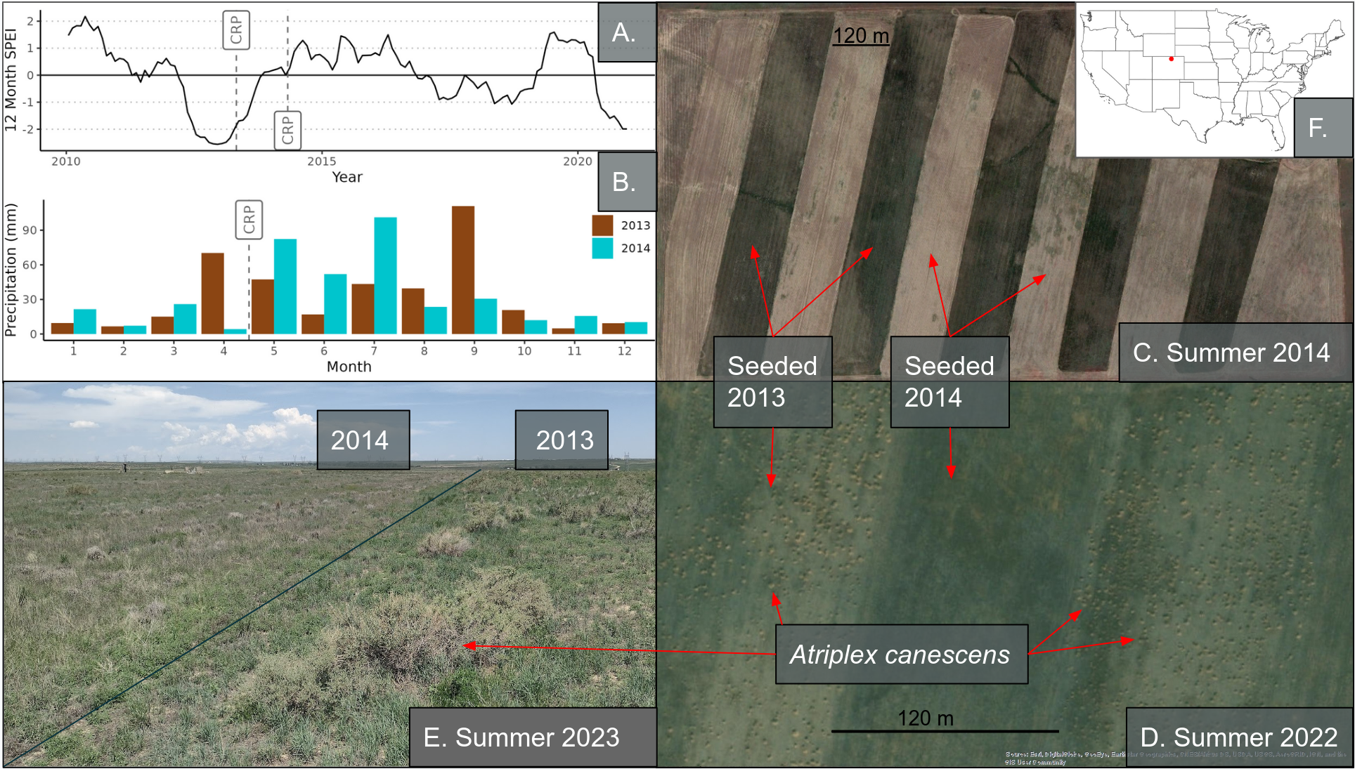

Figure 1

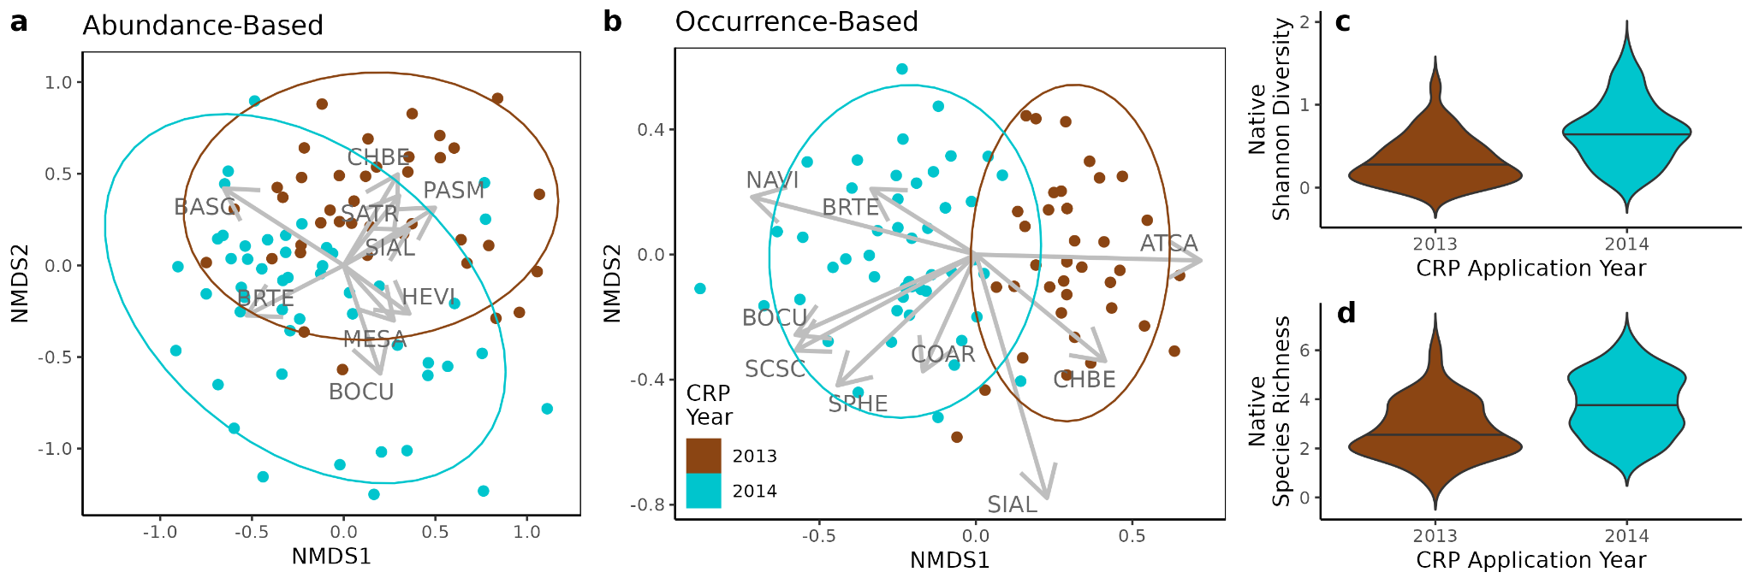

Figure 2

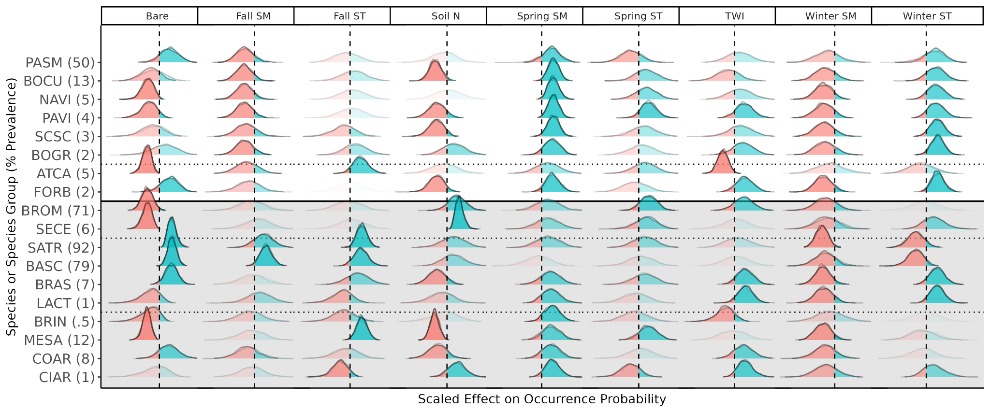

Figure 3

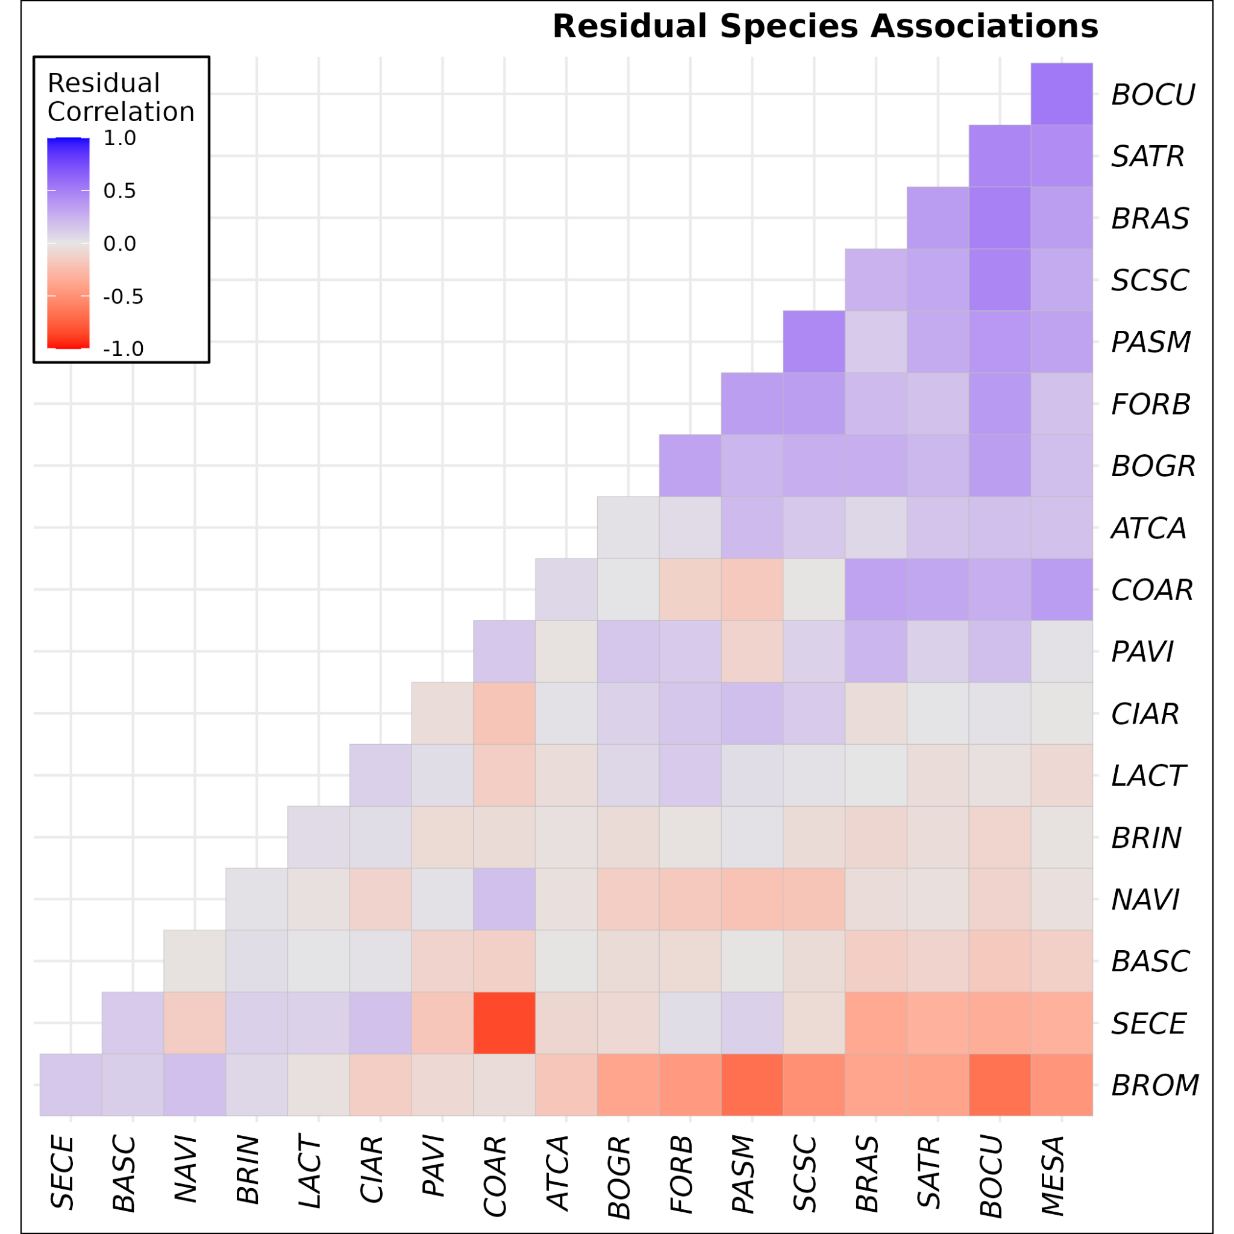

Figure 4

# Supplementary Figures and Tables

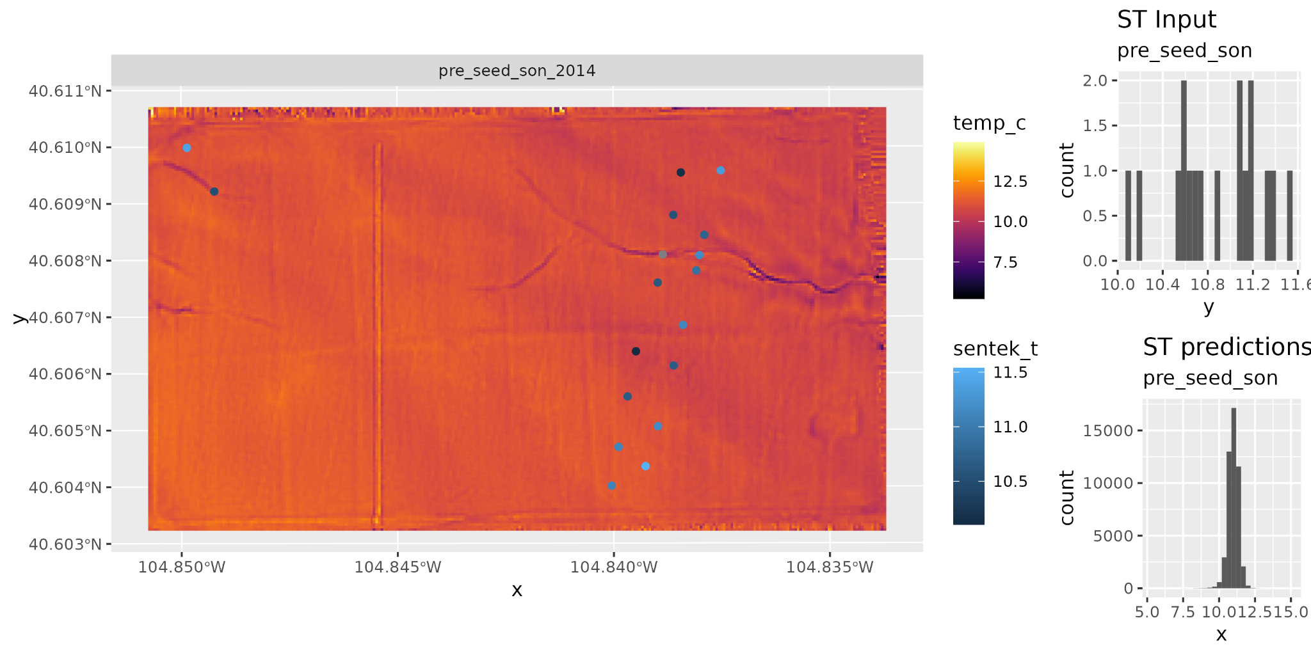

##### **Figure S1**. One of the surfaces created by spatial process modelling. Blue dots indicate the Sentek sensor locations. Figures for all surfaces used in the analysis, along with the code and data to recreate them, are available in the GitHub repository.

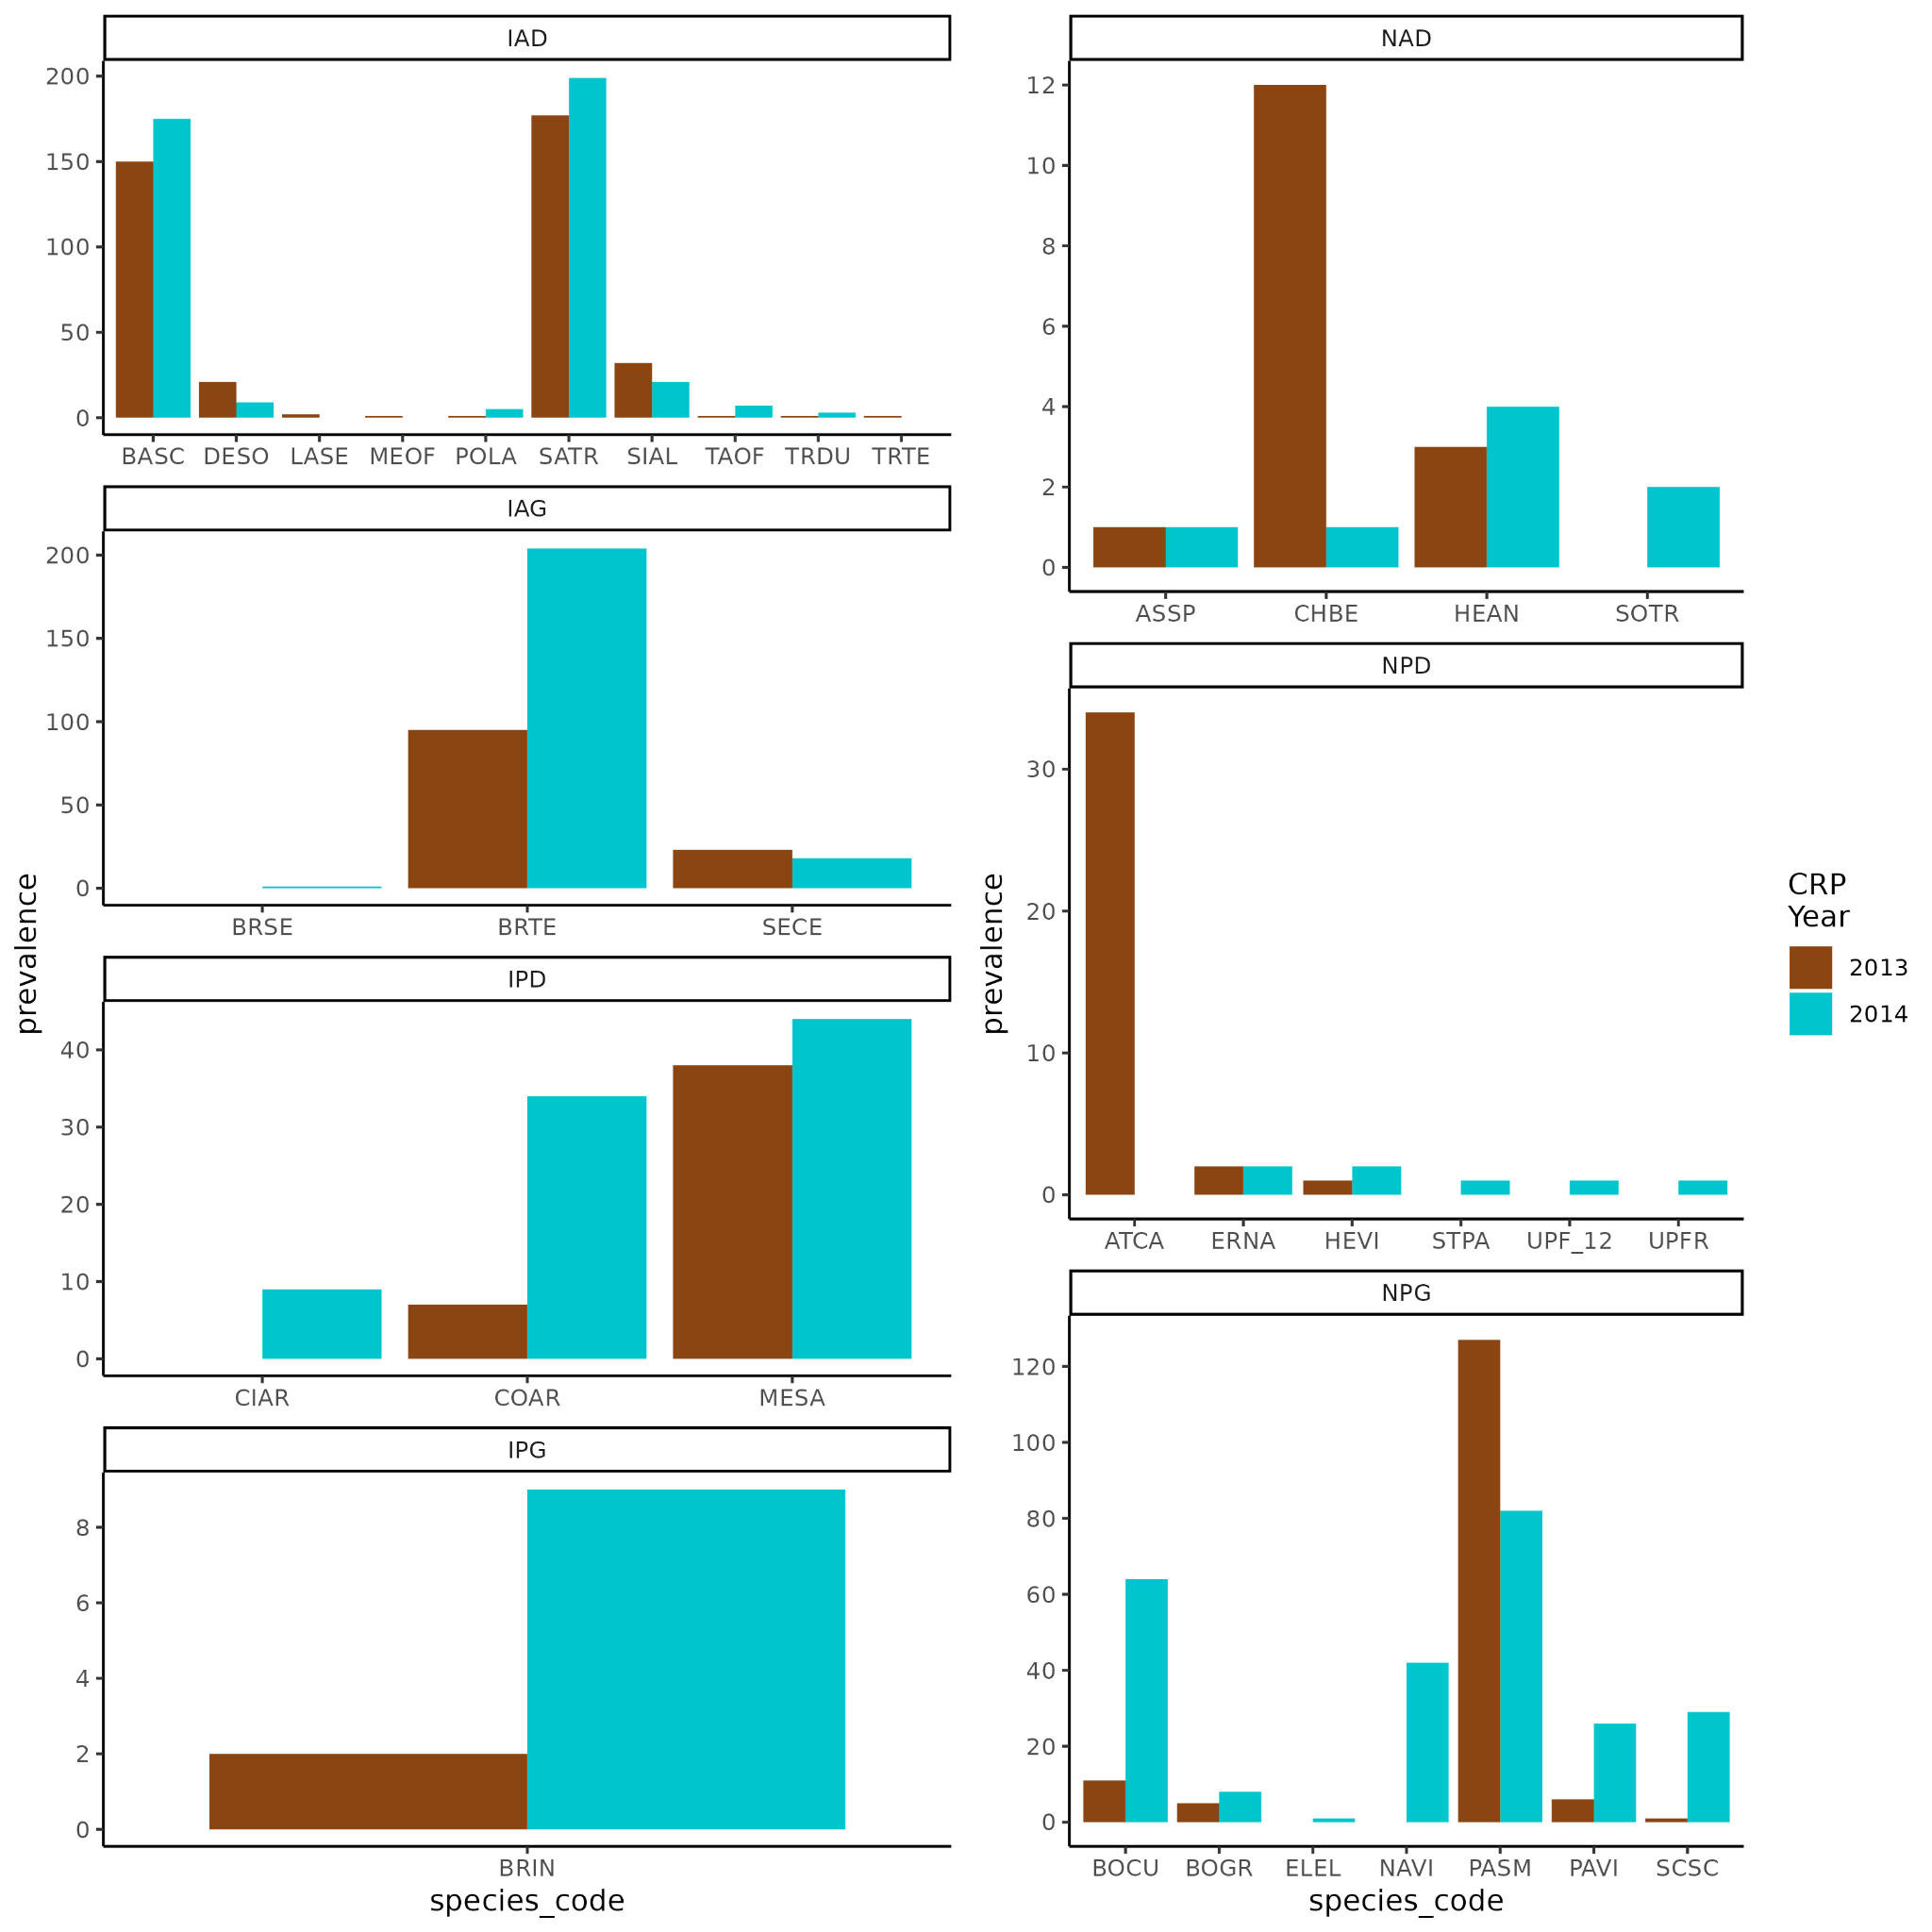

##### **Figure S2.** Species prevalence. Prevalence (number of plots in which a species was encountered) for each plant species encountered across the study site. Abbreviations: N = native, A = annual, P = perennial, D = dicot, G = graminoid, I = introduced.

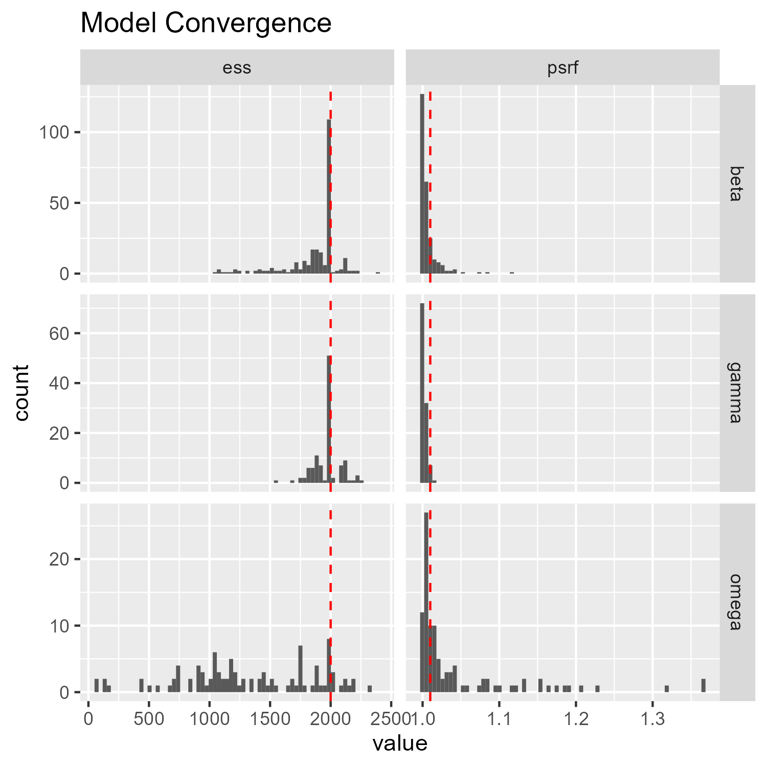

##### **FIgure S3:** Model convergence diagnostics. The potential scale reduction factor (PSRF) measures the convergence among chains, and being closer 1.0 is ideal. Effective sample size (ESS) measures autocorrelation between successive iterations within each chain, and higher values are better. Ideally ESS matches the number of posterior samples, but that is not fully necessary. Beta is the parameters for environmental filters, gammas are the parameters for the traits, and omega is the parameters for the species associations.

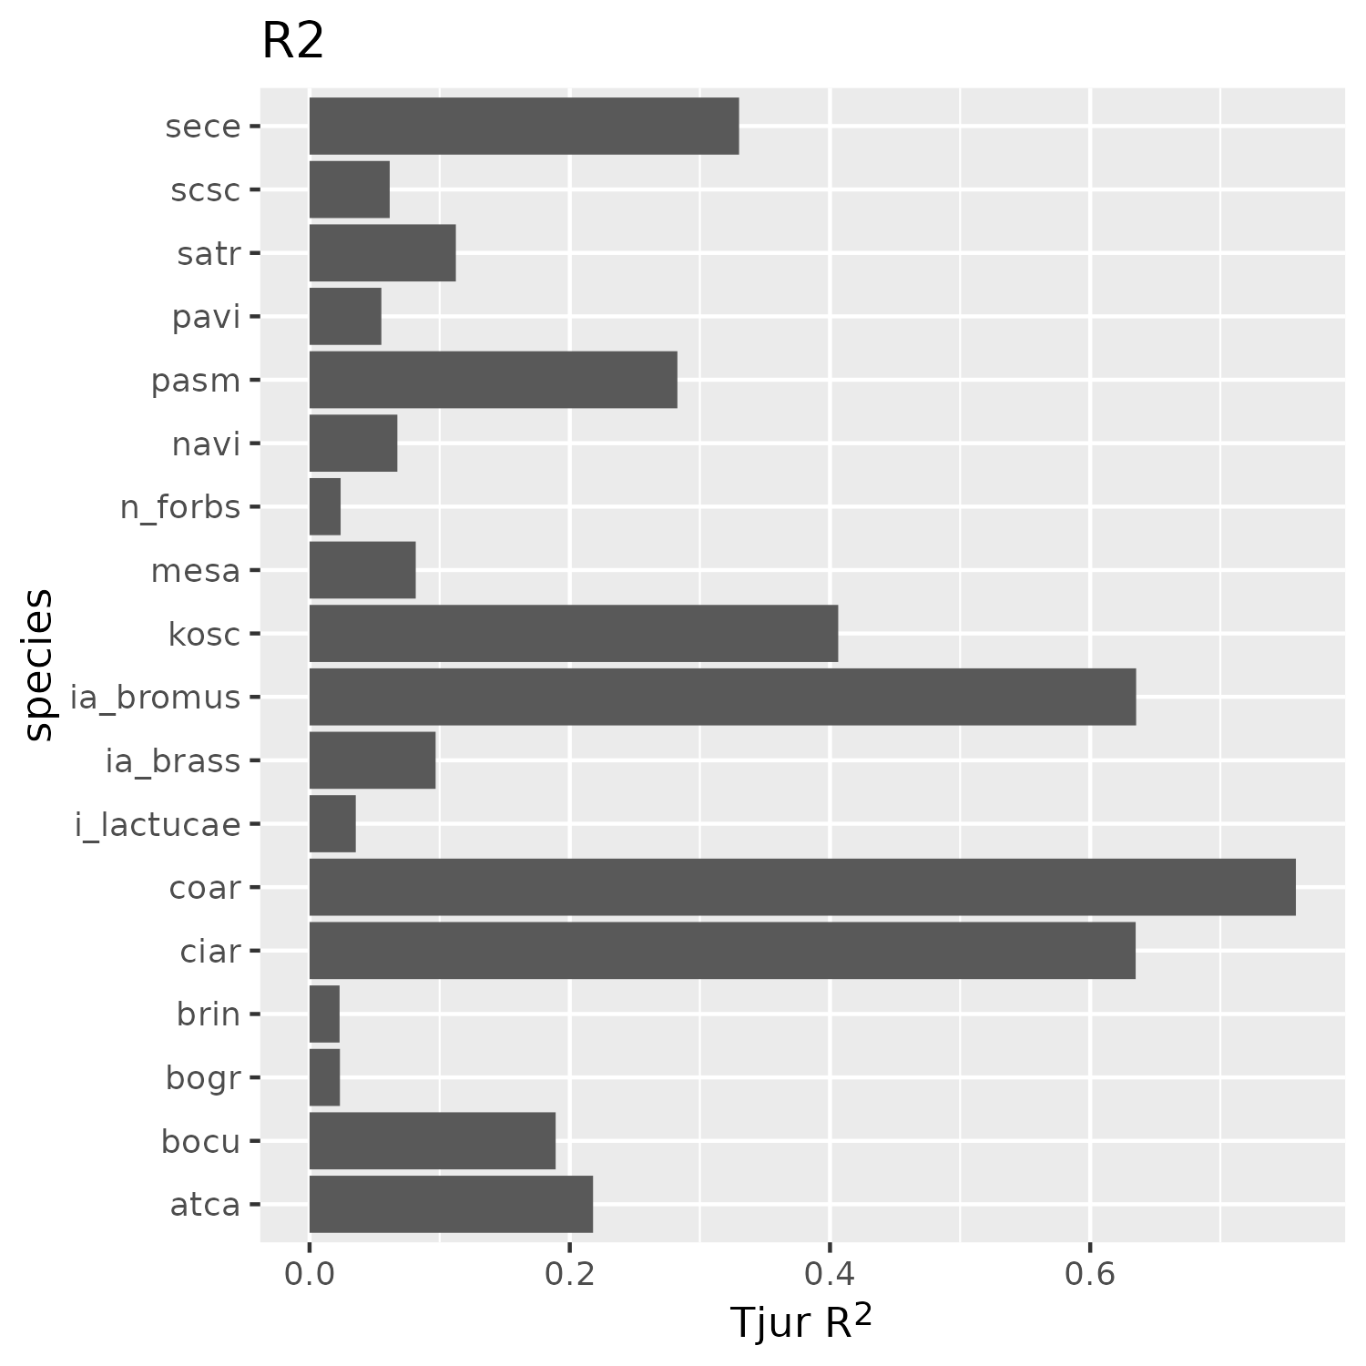

##### **Figure S4:** R2 values for each species or species group.

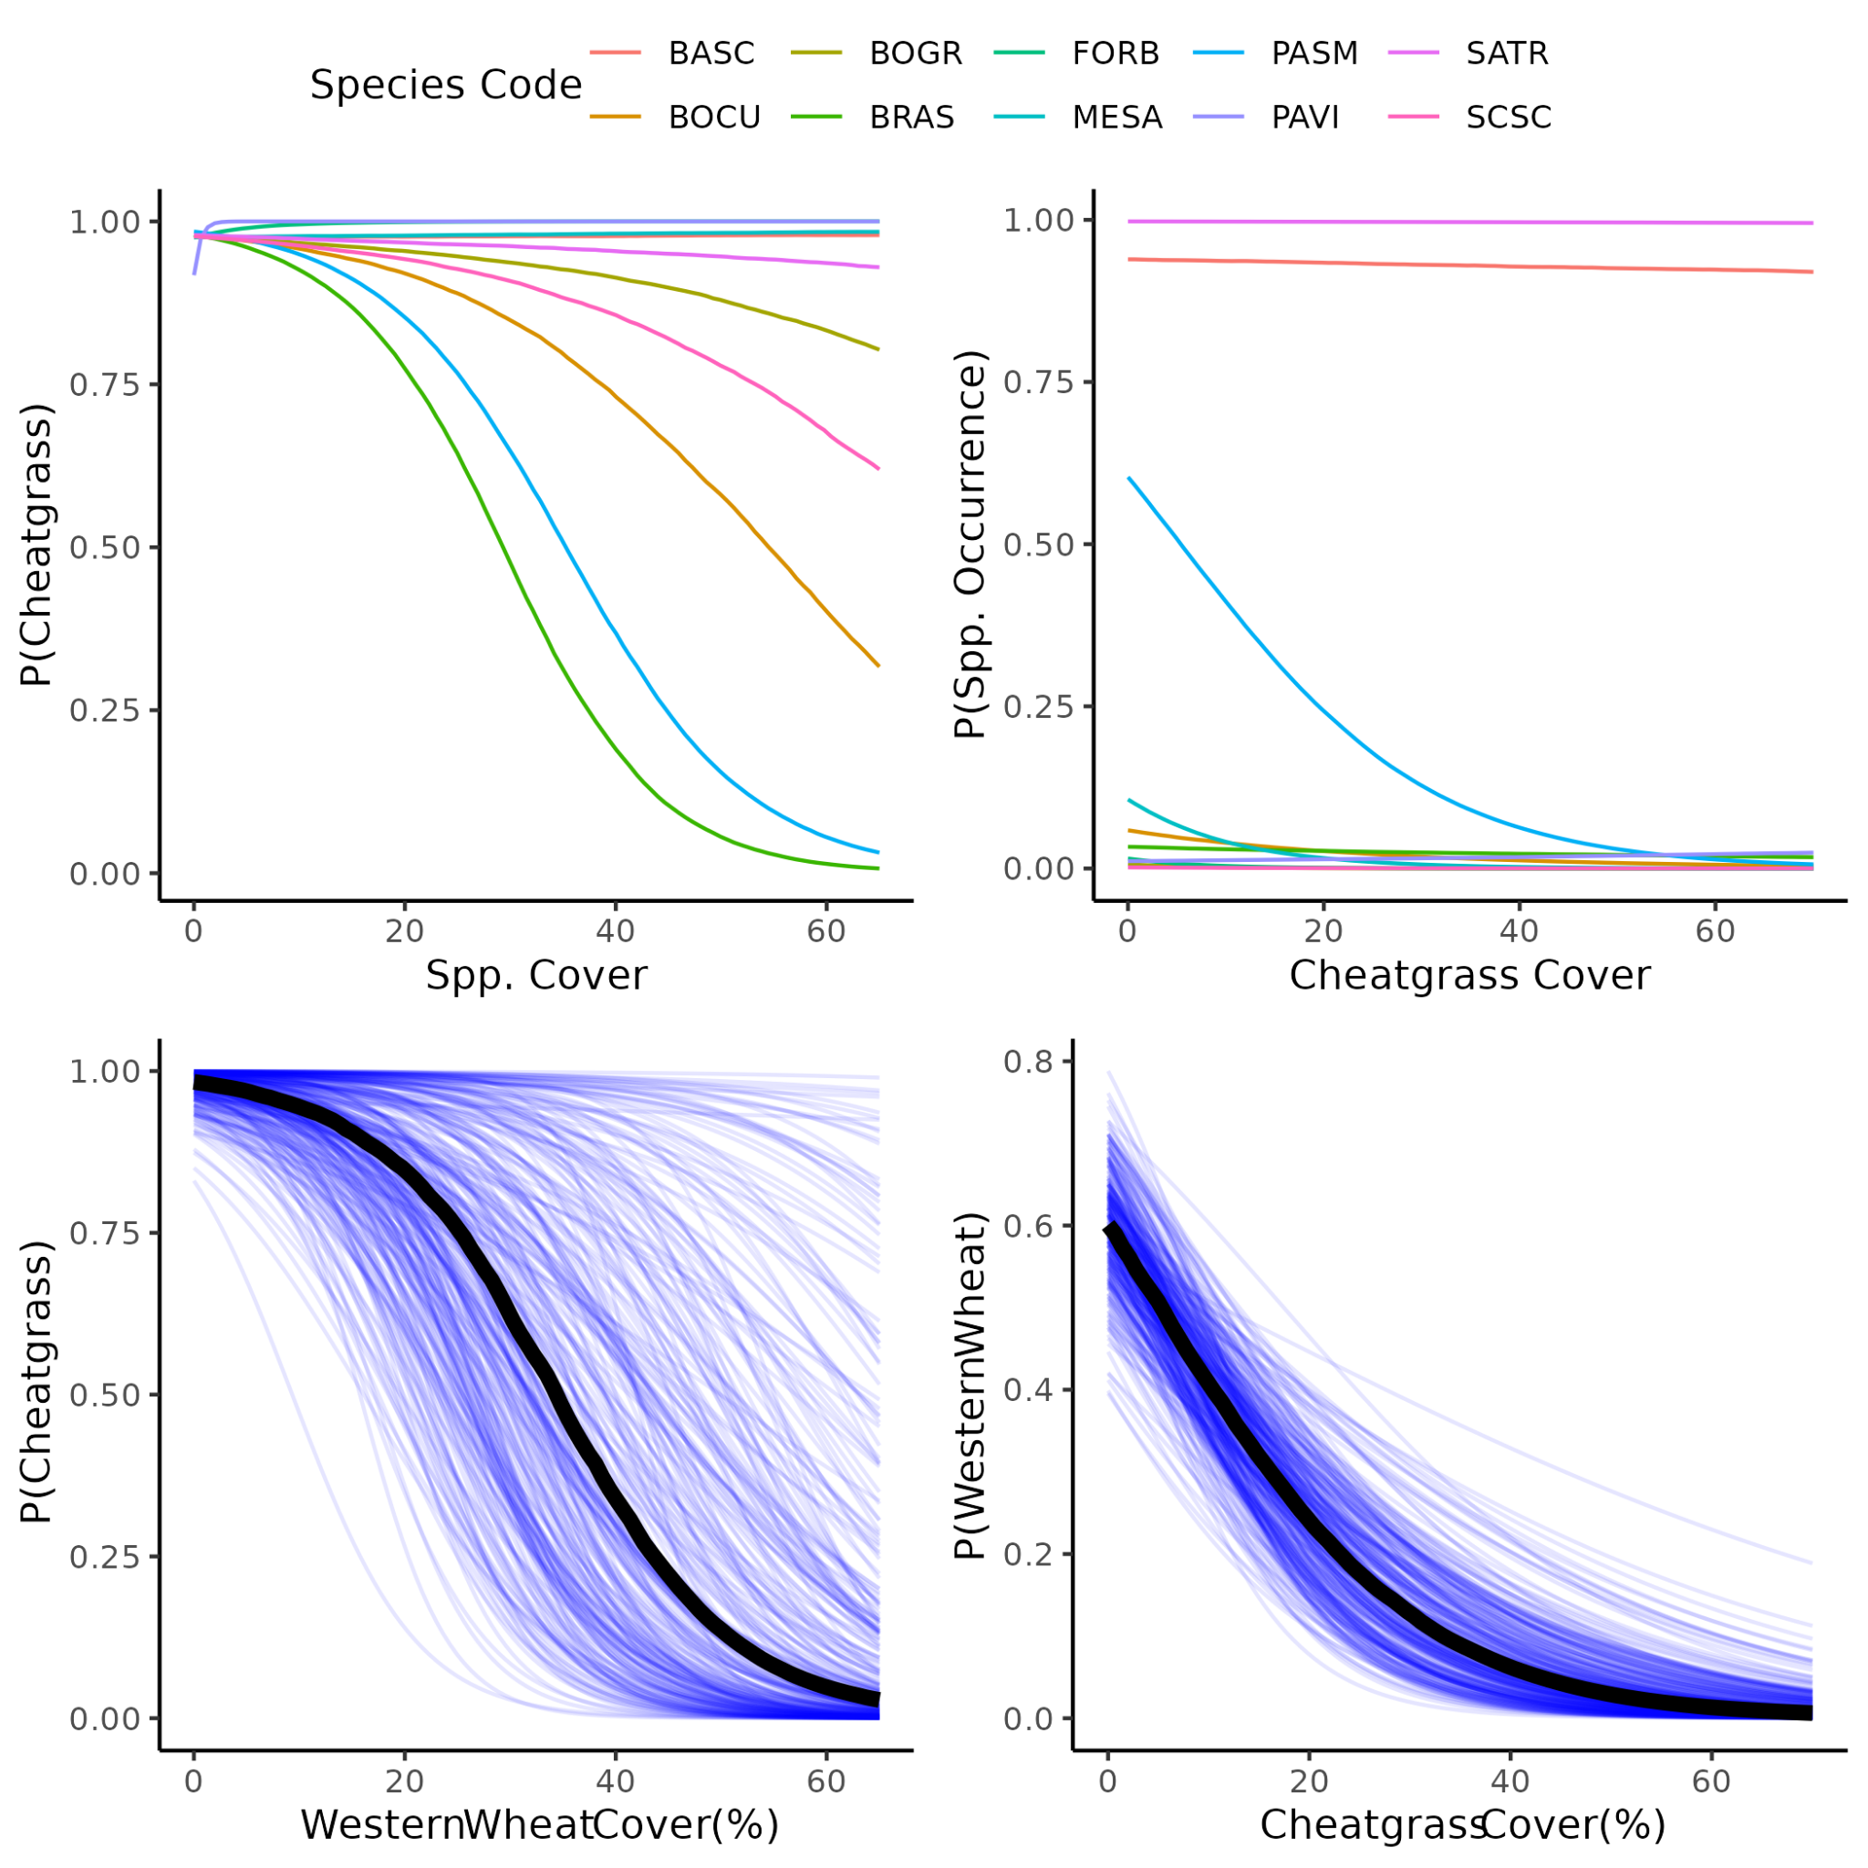

##### **Figure S5.** Western Wheatgrass and Cheatgrass interactions, compared to other species. This is using abundance data on the y axes to estimate the occurrence of a given species. P. smithii and cheatgrass had strong effects on each others’ occurrence, compared to other species. THis was consistent with field observations.

##### 

##### **Table S1**: All species encountered. Many species were encountered outside of the 0.1 m2 quadrats used for the JSDM, and so were not assigned to groups. Those species were still used in the diversity calculations.

|  |  |  |  |  |  |  |  |
| --- | --- | --- | --- | --- | --- | --- | --- |
| Family | Genus | Specific epithet | Group Code | Group Name | CRP Mix | origin | Seed Applied (kg/ha) |
| Asteraceae | *Gutierrezia* | *sarothrae* | GUSA | *Gutierrezia sarothrae* | no | n |  |
| Asteraceae | *Ericameria* | *nauseosa* | ERNA | *Ericameria nauseosa* | no | n |  |
| Asteraceae | *Heterotheca* | *villosa* | HEVI | *Heterotheca villosa* | no | n |  |
| Asteraceae | *Helianthus* | *annuus* | HEAN | *Helianthus annuus* | no | n |  |
| Asteraceae | *Stephanomeria* | *pauciflora* | FORB | Native Forbs | no | n |  |
| Asteraceae | cf *Aster* | d_081_herb_05 | FORB | Native Forbs | no | n |  |
| Asteraceae | *Antennaria* | sp. | ANSP | *Antennaria* sp | no | n |  |
| Asteraceae | *Artemisia* | *arbuscula* | ARAR | *Artemisia arbuscula* | no | n |  |
| Chenopodiaceae | *Atriplex* | *canescens* | ATCA | *Atriplex canescens* | yes | n | 0.2676 |
| Chenopodiaceae | *Chenopodium* | *berlandieri* | FORB | Native Forbs | no | n |  |
| Malvaceae | *Sphaerelcea* | *coccinea* | SPCO | *Sphaerelcea coccinea* | no | n |  |
| Papaveraceae | *Argemone* | cf *hispida* | ARHI | *Argemone cf hispida* | no | n |  |
| Poaceae | *Bouteloua* | *curtipendula* | BOCU | *Bouteloua curtipendula* | yes | n | 0.6244 |
| Poaceae | *Panicum* | *virgatum* | PAVI | *Panicum virgatum* | yes | n | 0.1784 |
| Poaceae | *Schizachyrium* | *scoparium* | SCSC | *Schizachyrium scoparium* | yes | n | 0.3568 |
| Poaceae | *Nassella* | *viridula* | NAVI | *Nassella viridula* | yes | n | 0.7136 |
| Poaceae | *Pascopyrum* | *smithii* | PASM | *Pascopyrum smithii* | yes | n | 1.784 |
| Poaceae | *Bouteloua* | *gracilis* | BOGR | *Bouteloua gracilis* | yes | n | 0.1784 |
| Poaceae | *Elymus* | *elymoides* | ELEL | *Elymus elymoides* | no | n |  |
| Solanaceae | *Solanum* | *triflorum* | FORB | Native Forbs | no | n |  |
| unknown | Perennial_forb | d_012_herb_01 | FORB | Native Forbs | no | n |  |
| unknown | Rhizomatous_perennial_forb | d_141_herb_09 | FORB | Native Forbs | no | n |  |
| Asteraceae | *Podospermum* | *laciniatum* | LACT | Introduced Cichorioideae | no | i |  |
| Asteraceae | *Taraxacum* | *officinale* | LACT | Introduced Cichorioideae | no | i |  |
| Asteraceae | *Tragopogon* | *dubious* | LACT | Introduced Cichorioideae | no | i |  |
| Asteraceae | *Cirsium* | *arvense* | CIAR | *Cirsium arvense* | no | i |  |
| Asteraceae | *Onopordium* | *acanthium* | ONAC | *Onopordium acanthium* | no | i |  |
| Asteraceae | *Lactuca* | *serriola* | LASE | *Lactuca serriola* | no | i |  |
| Brassicaceae | *Sisymbrium* | *altissimum* | BRAS | Introduced Brassicaceae | no | i |  |
| Brassicaceae | *Descurainia* | *sophia* | BRAS | Introduced Brassicaceae | no | i |  |
| Chenopodiaceae | *Salsola* | *tragus* | SATR | *Salsola tragus* | no | i |  |
| Chenopodiaceae | *Bassia* | *scoparia* | BASC | *Bassia scoparia* | no | i |  |
| Convolvulaceae | *Convolvulus* | *arvensis* | COAR | *Convolvulus arvensis* | no | i |  |
| Fabaceae | *Medicago* | *sativa* | MESA | *Medicago sativa* | yes | i | 0.3568 |
| Fabaceae | *Melilotus* | *officinale* | MEOF | *Melilotus officinale* | no | i |  |
| Poaceae | *Bromus* | *tectorum* | BROM | Introduced Annual *Bromus* | no | i |  |
| Poaceae | *Secale* | *cereale* | SECE | *Secale cereale* | no | i |  |
| Poaceae | *Bromus* | *inermis* | BRIN | *Bromus inermis* | no | i |  |
| Poaceae | *Bromus* | *secalinus* | BROM | Introduced Annual *Bromus* | no | i |  |
| Poaceae | *Agropyron* | *cristatum* | AGCR | *Agropyron cristatum* | no | i |  |
| Zygophyllaceae | *Tribulus* | *terrestris* | TRTE | *Tribulus terrestris* | no | i |  |

##### Table S2: R packages used in the analysis.

|  |  |  |
| --- | --- | --- |
| Package | Purpose | Citation |
| sf | Spatial vector data management | Pebesma 2018 |
| terra | Raster data management | Hijmans 2023a |
| raster | Raster data management | Hijmans 2023b |
| vegan | Diversity and NMDS | Oksanen et al 2022 |
| SPEI | Calculating SPEI | Beguería and Vicente-Serrano 2023 |
| microclima | Calculating air temperature | Mosedale et al 2023 |
| NicheMapR | Calculating air temperature | Kearney 2022 |
| topmodel | Calculating TWI | Buytaert 2022 |
| tidyverse | Data wrangling | Wickham et al 2019 |
| lubridate | Date wrangling | Grolemond and Wickham 2011 |
| vroom | Data wrangling | Hester et al 2023 |
| Hmsc | Joint species distribution modeling | Tikhonov et al 2023 |
| snow | parallelization | Tierney et al 2021 |
| fields | spatial process models | Nychka et al 2021 |
| ggpubr | visualization | Kassambara 2023 |
| ggcorrplot | visualization | Kassambara 2022 |
| ggthemes | visualization | Arnold 2021 |
| ggtext | visualization | Wilke 2021 |
| ggrepel | visualization | Slowikowski 2023 |
| ggmcmc | visualization | Fernandez i Marin 2016 |
| geomtextpath | visualization | Cameron and van den Brand 2022 |

##### **Table S3**. Species included in the CRP mix.

|  |  |  |  |
| --- | --- | --- | --- |
| Common Name | Scientific Name | Amount Applied (kg/ha) | Origin |
| Western wheatgrass | *Pascopyrum smithii* | 1.784 | native |
| Green needlegrass | *Nassela viridula* | 0.7136 | native |
| Sideoats gramma | *Bouteloua curtipendula* | 0.6244 | native |
| Alfalfa | *Medicago sativa* | 0.3568 | introduced |
| Little bluestem | *Schizachyrium scoparium* | 0.3568 | native |
| Fourwing Saltbush | *Atriplex canescens* | 0.2676 | native |
| Blue gramma | *Bouteloua gracilis* | 0.1784 | native |
| Switchgrass | *Panicum virgatum* | 0.1784 | native |

##### Supplementary References

Jeffrey B. Arnold (2021). ggthemes: Extra Themes, Scales and Geoms for 'ggplot2'. R package version 4.2.4.

[https://CRAN.R-project.org/package=ggthemes](https://cran.r-project.org/package=ggthemes)

Santiago Beguería and Sergio M. Vicente-Serrano (2023). SPEI: Calculation of the Standardized Precipitation-Evapotranspiration Index. R package version 1.8.1.

[https://CRAN.R-project.org/package=SPEI](https://cran.r-project.org/package=SPEI)

Wouter Buytaert (2022). topmodel: Implementation of the Hydrological Model TOPMODEL in R. R package version 0.7.5.

[https://CRAN.R-project.org/package=topmodel](https://cran.r-project.org/package=topmodel)

Allan Cameron and Teun van den Brand (2022). geomtextpath: Curved Text in 'ggplot2'. R package version 0.1.1.

[https://CRAN.R-project.org/package=geomtextpath](https://cran.r-project.org/package=geomtextpath)

Xavier Fernández i Marín (2016). ggmcmc: Analysis of MCMC Samples and Bayesian Inference. Journal of Statistical Software, 70(9), 1-20

[www.doi.org/10.18637/jss.v070.i09](http://www.doi.org/10.18637/jss.v070.i09)

Garrett Grolemund, Hadley Wickham (2011). Dates and Times Made Easy with lubridate. Journal of Statistical Software, 40(3), 1-25.

<https://www.jstatsoft.org/v40/i03/>

Jim Hester, Hadley Wickham and Jennifer Bryan (2023). vroom: Read and Write Rectangular Text Data Quickly. R package version 1.6.3.

[https://CRAN.R-project.org/package=vroom](https://cran.r-project.org/package=vroom)

Robert J. Hijmans (2023a). terra: Spatial Data Analysis. R package version 1.7-29.

[https://CRAN.R-project.org/package=terra](https://cran.r-project.org/package=terra)

Robert J. Hijmans (2023b). raster: Geographic Data Analysis and Modeling. R package version 3.6-20.

[https://CRAN.R-project.org/package=raster](https://cran.r-project.org/package=raster)

Alboukadel Kassambara (2022). ggcorrplot: Visualization of a Correlation Matrix using 'ggplot2'. R package

version 0.1.4. [https://CRAN.R-project.org/package=ggcorrplot](https://cran.r-project.org/package=ggcorrplot)

Alboukadel Kassambara (2023). ggpubr: 'ggplot2' Based Publication Ready Plots. R package version 0.6.0.

[https://CRAN.R-project.org/package=ggpubr](https://cran.r-project.org/package=ggpubr)

Michael Kearney (2022). NicheMapR: R implementation of Niche Mapper software for biophysical modelling. R package version 3.2.0.

<https://github.com/mrke/NicheMapR>

Jonathan Mosedale, Jonathan Bennie and James Duffy (2023). microclima: microclimate modelling with R. R package version 0.1.0.

<https://github.com/ilyamaclean/microclima>

Douglas Nychka, Reinhard Furrer, John Paige, Stephan Sain (2021). “fields: Tools for spatial data.” R package version 14.1.

<https://github.com/dnychka/fieldsRPackage>

Jari Oksanen, Gavin L. Simpson, F. Guillaume Blanchet, Roeland Kindt, Pierre Legendre, Peter R. Minchin, R.B. O'Hara, Peter Solymos, M. Henry H. Stevens, Eduard Szoecs, Helene Wagner, Matt Barbour, Michael Bedward, Ben Bolker, Daniel Borcard, Gustavo Carvalho, Michael Chirico, Miquel De Caceres, Sebastien Durand, Heloisa Beatriz Antoniazi Evangelista, Rich FitzJohn, Michael Friendly, Brendan Furneaux, Geoffrey Hannigan, Mark O. Hill, Leo Lahti, Dan McGlinn, Marie-Helene Ouellette, Eduardo Ribeiro Cunha, Tyler Smith, Adrian Stier, Cajo J.F. Ter Braak and James Weedon (2022). vegan: Community Ecology Package. R package version 2.6-4.

[https://CRAN.R-project.org/package=vegan](https://cran.r-project.org/package=vegan)

Pebesma, E., 2018. Simple Features for R: Standardized Support for Spatial Vector Data. The R Journal 10 (1), 439-446,

<https://doi.org/10.32614/RJ-2018-009>

Kamil Slowikowski (2023). ggrepel: Automatically Position Non-Overlapping Text Labels with 'ggplot2'. R package version 0.9.3.

[https://CRAN.R-project.org/package=ggrepel](https://cran.r-project.org/package=ggrepel)

Gleb Tikhonov, Otso Ovaskainen, Jari Oksanen, Melinda de Jonge, Oystein Opedal and Tad Dallas (2023). Hmsc: Hierarchical Model of Species Communities. R package version 3.0-14.

<https://www.helsinki.fi/en/researchgroups/statistical-ecology/software/hmsc>

Wickham H, Averick M, Bryan J, Chang W, McGowan LD, François R, Grolemund G, Hayes A, Henry L, Hester J, Kuhn M, Pedersen TL, Miller E, Bache SM, Müller K, Ooms J, Robinson D, Seidel DP, Spinu V, Takahashi K, Vaughan D, Wilke, Woo K, Yutani H (2019). “Welcome to the tidyverse.” Journal of Open Source Software, 4(43), 1686.

<https://doi.org/10.21105/joss.01686>

Claus O. Wilke and Brenton M. Wiernik (2022). ggtext: Improved Text Rendering Support for 'ggplot2'. R package version 0.1.2.

[https://CRAN.R-project.org/package=ggtext](https://cran.r-project.org/package=ggtext)